**Chapter 12- Reconstruction Document Based Questions Packet**

**Essential Question of the Chapter:** Did Reconstruction successfully solve the problems caused by slavery and the Civil War?

The period of **Reconstruction** lasted from 1865 to 1877, and involved putting the country back together after the Civil War. The Civil War was fought and won by the North and the United States was preserved; but a number of new problems were created. Four million slaves were suddenly freed, but did not have jobs, an education, places to live, or a guarantee of basic civil rights. Northerners and Southerners, who had just spent five years slaughtering each other by the thousands, bitterly resented one another and were now forced to share the country once again. Many Southern whites had their land or families destroyed during the Civil War, and had to rebuild their lives from scratch. Those who survived still held many of the same racist attitudes and resentments towards blacks, and did not want to include them in society.

**Document Collection 1:**

Secondary Excerpt from “Americans” textbook regarding divisions between the North and South.

**To Punish the South or Not**

Many people wanted the South to be punished for trying to leave the Union. Other people, however, wanted to forgive the South and let the healing of the nation begin.

**Lincoln's Plan for Reconstruction**

Abraham Lincoln wanted to be lenient to the South and make it easy for southern states to rejoin the Union. He said that any southerner who took an oath to the Union would be given a pardon. He also said that if 10% of the voters in a state supported the Union, then a state could be readmitted. Under Lincoln's plan, any state that was readmitted must make slavery illegal as part of their constitution.

**President Johnson**

President Lincoln was assassinated at the end of the Civil War, however, and never had the chance to implement his Reconstruction plan. When Andrew Johnson became president, he was from the South and wanted to be even more lenient to the Confederate States than Lincoln was. Congress, however, disagreed and began to pass harsher laws for the Southern states.

**1. What was one of the issues that Americans had to deal with following the Civil War?**

**2. In your own words, describe Lincoln’s Plan for Reconstruction**

**3. In your own words, describe Johnson’s Plan for Reconstruction**

**Document Collection 2: Protecting the Civil Rights of Former Slaves**

*In addition to finding jobs and homes, Reconstruction aimed to protect the freedom and civil rights of newly freed slaves. The 13th, 14th, and 15th Amendments to the Constitution aimed to ensure the equality of all people in the United States.*

**Source 1:** The 13th, 14th, and 15th Amendments

**Amendment 13 (1865):**

Neither slavery nor involuntary servitude, except as punishment for crime whereof the party shall have been duly convicted, shall exist within the United States, or and place subject to their jurisdiction....

**Amendment 14 (1868):**

All persons born or naturalized in the United States, and subject to the jurisdiction thereof, are citizens of the United States and of the State wherein they reside. No state shall make or enforce any law, which shall abridge the privileges or immunities of citizens of the United States; nor shall any State deprive any person of life, liberty, or property, without due process of law; nor deny to any person within its jurisdiction the equal protection of the laws...

**Amendment 15 (1870):**

The right of citizens of the United States to vote shall not be denied or abridged by the United States or by any State because of race, color, or previous conditions of servitude...

4. What is outlawed with the 13th Amendment?

5. What does the 14th Amendment essential do for African Americans?

6. What right was given with the 15th Amendment?

7. Why do you think these Amendments would be important following the Civil War?

**Document Collection 3: Integration**

*The issue of integrating freed slaves into American society involved more than just finding homes and jobs for the free blacks, it also meant involving them in every aspect of American life. Despite the protection of the 13th, 14th, and 15th Amendments, Southern states created hundreds of laws that kept blacks and whites completely segregated from one another, nicknamed the “Jim Crow Laws.”*

**Source 1:** In the years following the Civil War - throughout the South -state, city, and town governments passed laws to restrict the rights of free African-American men and women. These laws were called “Black Codes.” The example below of “Black Codes” comes from laws passed in Opelousas, Louisiana immediately after the Civil War.

1. "No negro or freedmen shall be allowed to come within the limits of the town of Opelousas without special permission from his employers. Whoever breaks this law will go to jail and work for two days on the public streets, or pay a fine of five dollars.”

2. “No negro or freedman shall be permitted to rent or keep a house in town under any circumstances. No negro or freedman shall live within the town who does not work for some white person or former owner.”

3. “No public meetings of negroes or freedmen shall be allowed within the town.”

4. “No freedman shall be allowed to carry firearms, or any kind of weapons. No freedman shall sell or exchange any article of merchandise within the limits of Opelousas without permission in writing from his employer.”

5. “Every Negro is to be in the service of (work for) some white person, or former owner.”

8. What are Black Codes?

9. According to the Black Codes of Opelousas, Louisiana, where were freedman allowed to live? What was the fine for breaking this law?

10. What is the only way a freedman could live within the town?

11. What is being prevented in point #3?

12. What items were being prevented in point #4?

13. Could a freedman in Opelousas be a business owner? What does the law say in point #5?

**Document Collection 4: Incorporating Former Slaves into American Society**

*One of the most difficult challenges the nation faced following the Civil War involved creating jobs and homes for four million former slaves. The answer for many was called sharecropping, or renting out land to freed slaves and allowing them to pay their rent by selling the crops produced on it. Often these small pieces of land did not produce much, or the contracts were extremely biased against blacks, and so many found freedmen found themselves owing money to their former masters---and spending the rest of their lives in poverty to pay it off.*

**Source 1:** Excerpt from *Senate Report 693, 46th Congress, 2nd Session (1880).*   
*Freed by the Emancipation Proclamation in 1865, former slave Henry Adams testified before the U.S. Senate fifteen years later about the early days of his freedom, describing the process of sharecropping.*

The white men read a paper to all of us colored people telling us that we were free and could go where we pleased and work for who we pleased. The man I belonged to told me it was best to stay with him. He said, “The bad white men was mad with the Negroes because they were free and they would kill you all for fun.” He said, stay where we are living and we could get protection from our old masters.

I told him I thought that every man, when he was free, could have his rights and protect themselves. He said, “The colored people could never protect themselves among the white people. So you had all better stay with the white people who raised you and make contracts with them to work by the year for one-fifth of all you make. And next year you can get one-third, and the next you maybe work for one-half you make. We have contracts for you all to sign, to work for one-twentieth you make from now until the crop is ended, and then next year you all can make another crop and get more of it.”

I told him I would not sign anything. I said, “I might sign to be killed. I believe the white people is trying to fool us.” But he said again, “Sign this contract so I can take it to the Yankees and have it recorded.” All our colored people signed it but myself and a boy named Samuel Jefferson. All who lived on the place was about sixty, young and old.  
 On the day after all had signed the contracts, we went to cutting oats. I asked the boss, “Could we get any of the oats?” He said, “No; the oats were made before you were free.” After that he told us to get timber to build a sugar-mill to make molasses. We did so. On the 13th day of July 1865 we started to pull fodder. I asked the boss would he make a bargain to give us half of all the fodder we would pull. He said we may pull two or three stacks and then we could have all the other. I told him we wanted half, so if we only pulled two or three stacks we would get half of that. He said, “All right.” We got that and part of the corn we made. We made five bales of cotton but we did not get a pound of that. We made two or three hundred gallons of molasses and only got what we could eat. We made about eight-hundred bushel of potatoes; we got a few to eat. We split rails three or four weeks and got not a cent for that.

14. Based on the above account, what did the former slave owner suggest to the freedman? Why would he suggest that?

15. Explain the terms of the “contract.”

16. How many people signed the contract? Who did not sign the contract?

17. What actually occurred on the plantation after the freedman decided to stay and work?



18. Explain how sharecropping is similar to and different from slavery.

**Document Collection 5: Healing the Divisions between North and South**

*The Civil War created many divisions between the Northern and Southern United States, which included divides along racial and political party lines.*

**Source 1:** 1860 Election Map

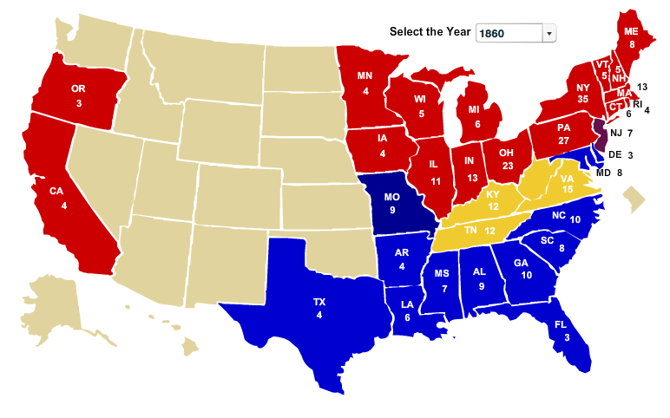

**19. According the election of 1860, what seems to be happening with the country? What observations do you notice?**

**Source 2:** Voting Propaganda (1868)

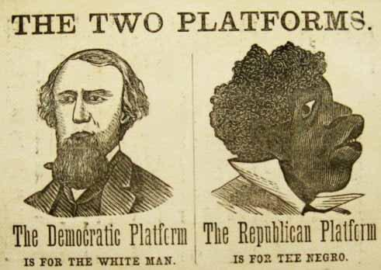

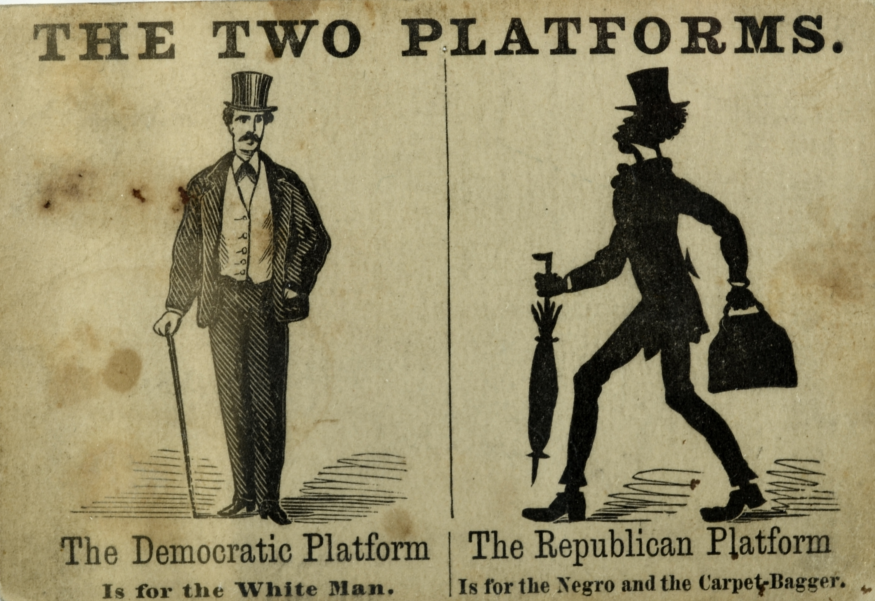

**20. In the pictures above, what is the message that is being said in regards to the two political parties?**

**Source 2:** Harper’s Weekly, October 21, 1876.

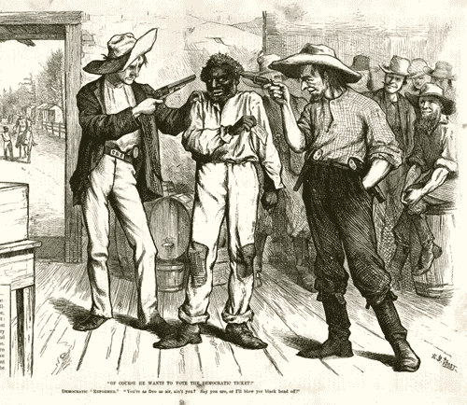

*First white man: “Of course he wants to vote for the democratic ticket!”*

*Second white man: “You’re as free as air, ain’t you? Say you are, or I’ll blow your black head off!”*

21. During the Civil War, what political party was associated with Emancipation? What political party did Lincoln belong to?

22. What are the white men persuading the freedman to do? How are they persuading him?

**Source 3:** Abram Colby, testimony to a joint House and Senate Committee in 1872.

Note: Colby was a former slave who was elected to the Georgia State legislature during Reconstruction.

Colby: On the 29th of October 1869, [the Klansmen] broke my door open, took me out of bed, took me to the woods and whipped me three hours or more and left me for dead. They said to me, "Do you think you will ever vote another damned Radical ticket?" I said, "If there was an election tomorrow, I would vote the Radical ticket." They set in and whipped me a thousand licks more, with sticks and straps that had buckles on the ends of them.

Colby: Some are first-class men in our town. One is a lawyer, one a doctor, and some are farmers… They said I had voted for Grant and had carried the Negroes against them. About two days before they whipped me they offered me $5,000 to go with them and said they would pay me $2,500 in cash if I would let another man go to the legislature in my place. I told them that I would not do it if they would give me all the county was worth… No man can make a free speech in my county. I do not believe it can be done anywhere in Georgia.

23. Describe the events that took place on Oct. 29th to Abram Colby?

24. What political party would be considered “radical” in the south?

25. Who were the men that assaulted Abram?

26. What were the Klansmen trying to accomplish before they whipped Abram?

**Document Collection 7: Racial Violence**

*Although African Americans had long been the targets of racial violence, the Reconstruction Era brought new waves of brutality to the North and South. Hate groups like the Ku Klux Klan spread terror across the nation as the government struggled to contain the hate crimes they committed.*

**Source 1:** Worse Than Slavery (Thomas Nast, 1874) 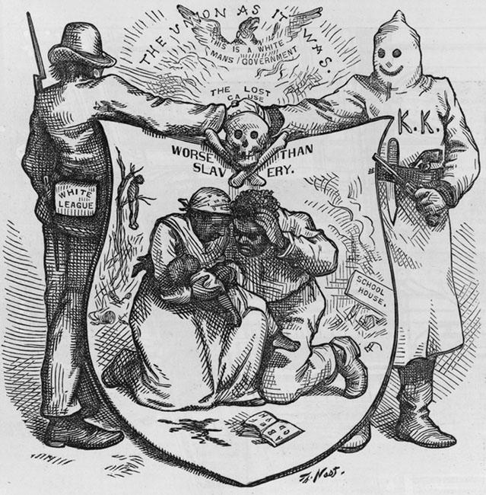

27. Why do you think this image is called, “Worse than Slavery”?

**Source 2:** Albion Tourgee, Letter on Ku Klux Klan Activities. New York Tribune, May 1870.

Note: *Tourgee was a white, Northern soldier who settled in North Carolina after the War. He served as a judge during Reconstruction and wrote this letter to the North Carolina Republican Senator, Joseph Carter Abbott.*

It is my mournful duty to inform you that our friend John W. Stephens, State Senator from Caswell, is dead. He was foully murdered by the Ku-Klux in the Grand Jury room of the Court House on Saturday… He was stabbed five or six times, and then hanged on a hook in the Grand Jury room… Another brave, honest Republican citizen has met his fate at the hands of these fiends…

I have very little doubt that I shall be one of the next victims. My steps have been dogged for months, and only a good opportunity has been wanting to secure to me the fate which Stephens has just met… I say to you plainly that any member of Congress who, especially if from the South, does not support, advocate, and urge immediate, active, and thorough measures to put an end to these outrages…is a coward, a traitor, or a fool.

28. Whom did the KKK murder?

29. Describe how the KK murdered Stephens

30. What political party did Stephens belong too?

31. Albion Tourgee says in the 2nd paragraph that he fears something. What is it?

32. What is Tourgee trying to accomplish in this message?