- 1934 Night of Long Knives
- 1933-1935 Jews humiliated and excluded from public jobs
- 1935 Nuremberg Laws – separation of Aryans and Jews
- 1932 – 1936 – 6 million to 1.5 million unemployment by 1937 only 400,000 labor shortage
- Cartels, unions a part of the political party
- 1938 Kristallnacht
- 1933 – 1939 – $8 million to $135 million spent on army – armed aggression
- 1942 - Wannsee Conference – The Final Solution\Himmler
- https://www.youtube.com/watch?v=L90smU0SOcQ

Steps to War
1931 Japan seizes Manchuria
1935 (March) Hitler tears up the Treaty of Versailles
(Oct.) Italy invades Ethiopia
1936 (March) German troops reoccupy the Rhineland \ Tipping Point
- France was stronger and Hitler would have backed down. Why?
- Gives Hitler confidence and shows Europe’s weakness
- Military and popular support for Hitler swells in Germany
1936 (July) Spanish Civil War
1936 (Oct.) Rome Berlin Axis
1937 Japan and China go to war
Lebensraum
1938 (March) Germany Anschluss Austria
1938 (Sept.) Munich Conference
- Appeasement
- Sudetenland – part of Czech.
- Poland the line in the sand
- “Peace in our time” – Chamberlin – 1 year
Blitzkrieg \ Pervitin
1939 (March) Germany invades Czechoslovakia
(Aug.) German Soviet Non Aggression Pact
(Sept.) Germany and Russia invade Poland Gleiwitz Incident\ Blitzkrieg
(Sept.) France \ Great Britain declare war
(Sept.) Russia gets Estonia, Latvia, and Lithuania
(Nov.) Russia invades Finland
Phony War or Sitzkrieg
1940 (April) Germany invades Denmark – 24 hrs
(April) Germany invades Norway – 48 hrs
(May) Germany invades Netherlands, Luxembourg, and Belgium
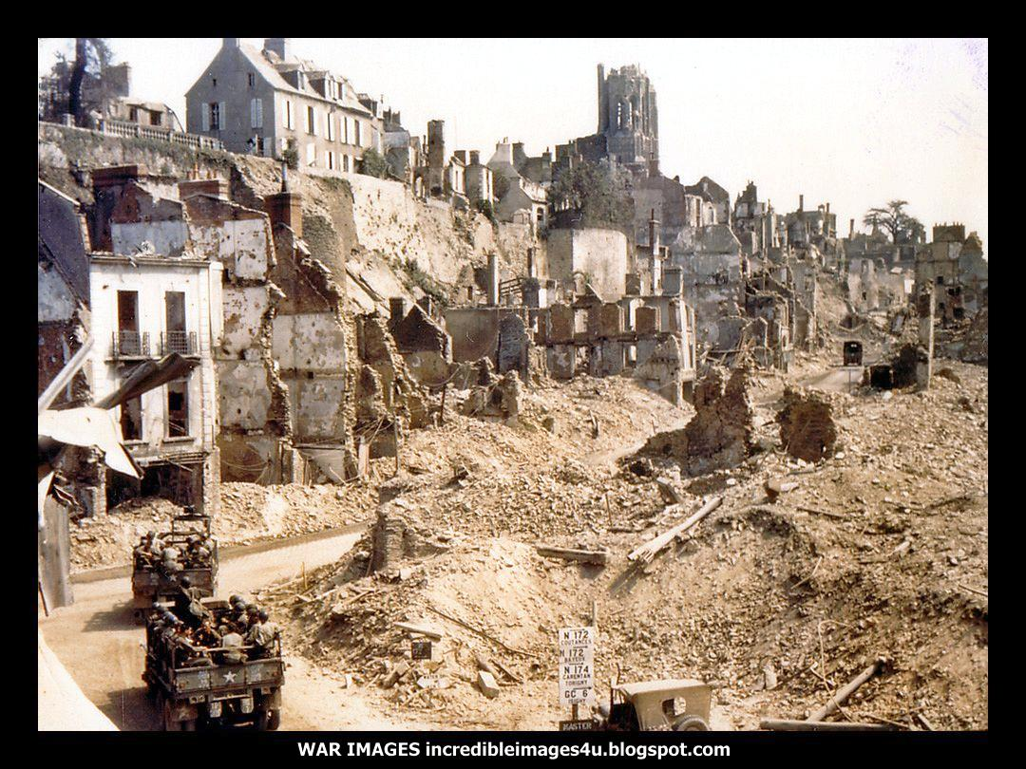
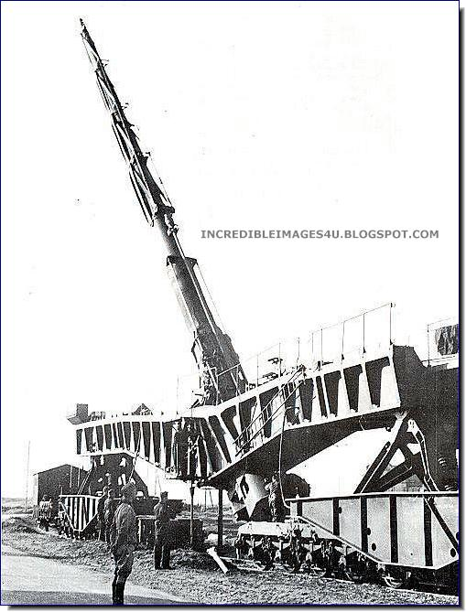
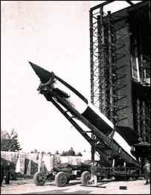
(May) Germany invades France going around 2 million troops stationed at the Maginot Line which cost lots of money
Battle of Dunkirk – 330,000
1940 (June) France surrenders
"HERE ON THE ELEVENTH OF NOVEMBER 1918 SUCCUMBED THE CRIMINAL PRIDE OF THE GERMAN EMPIRE... VANQUISHED BY THE FREE PEOPLES WHICH IT TRIED TO ENSLAVE."
Railcar, day, place, chair, got up just like Marshal Foch did to show disdain, harsh terms
The Armistice site was demolished by the Germans on Hitler's orders three days later. The carriage itself was taken to Berlin as a trophy of war, along with pieces of a large stone tablet.
The Alsace-Lorraine Monument (depicting a German eagle impaled by a sword) was destroyed and all evidence of the site was obliterated, with the notable exception of the statue of Marshal Foch: Hitler intentionally ordered it to be left intact so that it would be honoring only a wasteland.

Vichy Regime - Petain
Free French - Charles de Gaul
Battle of Britain – air battle, Luftwaffe, RAF, Radar 7ui
Operation Barbarossa – German Russian conflict
Battle of Stalingrad – 2 million soldiers, worst battle and largest battle of human history, 40,000 civilian, turning point
"Surrender is forbidden. 6 Army will hold their positions to the last man and the last round and by their heroic endurance will make an unforgettable contribution towards the establishment of a defensive front and the salvation of the Western world."

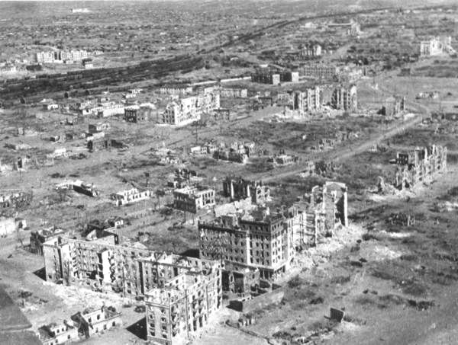

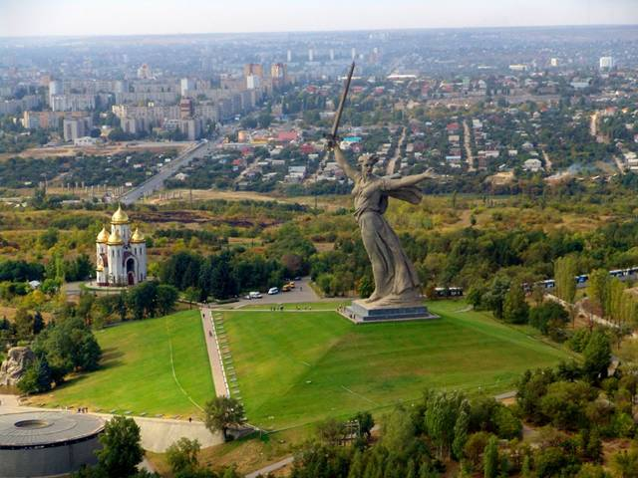
The Motherland Calls
Sino Japanese War II
Rape of Nanking – 300,000 – “Smiling soldiers can be seen conducting bayonet practice on live prisoners, decapitating them and displaying severed heads as souvenirs, and proudly standing among mutilated corpses. Some of the Chinese POWs were simply mowed down by machine-gun fire while others were tied-up, soaked with gasoline and burned alive.
After the destruction of the POWs, the soldiers turned their attention to the women of Nanking and an outright animalistic hunt ensued. Old women over the age of 70 as well as little girls under the age of 8 were dragged off to be sexually abused. More than 20,000 females (with some estimates as high as 80,000) were gang-raped by Japanese soldiers, then stabbed to death with bayonets or shot so they could never bear witness.
Pregnant women were not spared. In several instances, they were raped, then had their bellies slit open and the fetuses torn out. Sometimes, after storming into a house and encountering a whole family, the Japanese forced Chinese men to rape their own daughters, sons to rape their mothers, and brothers their sisters, while the rest of the family was made to watch.”
50,000 addicted to drugs to control them
Comfort Women
- USS Panay – Yangtze River
- Expansionism
- Flying tigers
- US oil embargo – 80% - leave China or fight
- General Tojo – new military prime minister
Operation Gunnerside
D-Day – June 6 1944 – Juno, Gold, Sword, Omaha, and Utah - Eisenhower
- Until the very last minute, the place of invasion - Normandy - was the most heavily guarded secret on the planet.
- Even the units conducting the initial assaults did not know the locations of their landings.
- Surprise was crucial since Germany had 55 divisions in France - the Allies could transport no more than 8 divisions on D-Day morning.
- It is estimated that nearly 2 million soldiers, sailors and airmen were involved in Operation Overlord, including U.S., British, and Canadians who were scheduled to fight after men on the ground secured a Normandy bridgehead.
- 195,000 naval personnel manned 6,939 naval vessels (including 1,200 warships and 15 hospital ships).
- About 17 million maps supported the mission.
- The United States shipped 7 million tons of supplies (that translates into 14 billion pounds of material).
- Of those supplies, ammunition accounted for 448,000 tons.
- Instead of two days, it took Germany's 2nd Waffen SS Division two weeks to reach the front. Allied air power, Eisenhower's spies and French Resistance contacts all contributed to that result.
- There are 9,386 graves in the American cemetery at Colleville-sur-Mer. Each grave faces west, toward America.

Operation Fortitude: Patton
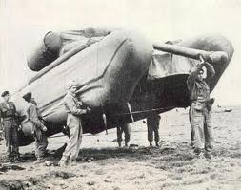
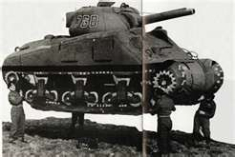

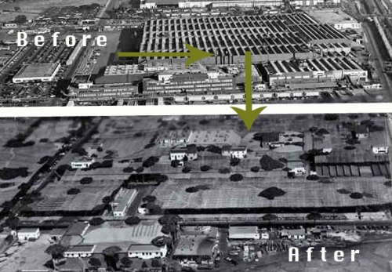
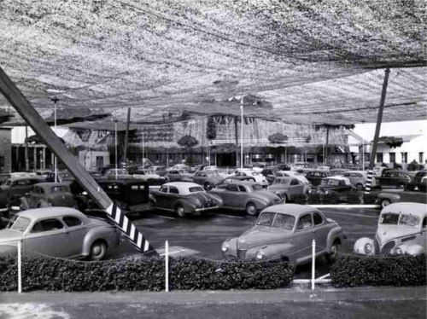

Battle of El Alamein: Montgomery vs. Rommel the Desert Fox and the Afrika Korps – Suez Canal
Italy the soft underbelly
Battle of the Bulge
Patton:
http://www.youtube.com/watch?v=g-0dTpzNzwo
Lead me, follow me, or get out of my way
When we land against the enemy, don't forget to hit him and hit him hard. When we meet the enemy we will kill him. We will show him no mercy. He has killed thousands of your comrades and he must die. If you company officers in leading your men against the enemy find him shooting at you and when you get within two hundred yards of him he wishes to surrender – oh no! That bastard will die! You will kill him. Stick him between the third and fourth ribs. You will tell your men that. They must have the killer instinct. Tell them to stick him. Stick him in the liver. We will get the name of killers and killers are immortal. When word reaches him that he is being faced by a killer battalion he will fight less. We must build up that name as killers.
Fake Army Fake Speeches
Italy
European Theatre
Conspiracy Theory
Battle for Berlin
V-E Day May 8 1945
V-J Day Aug. 15 1945
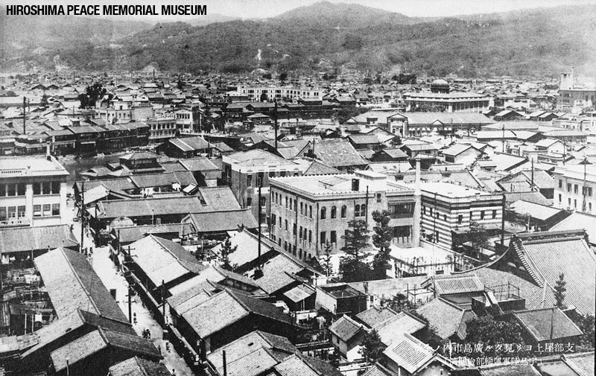

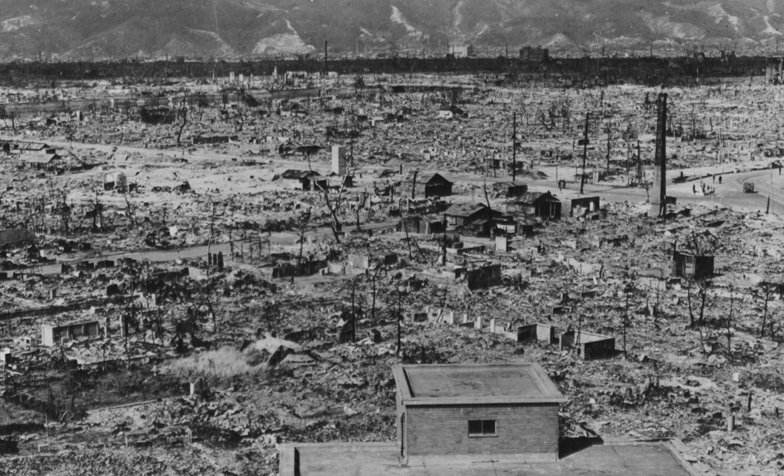
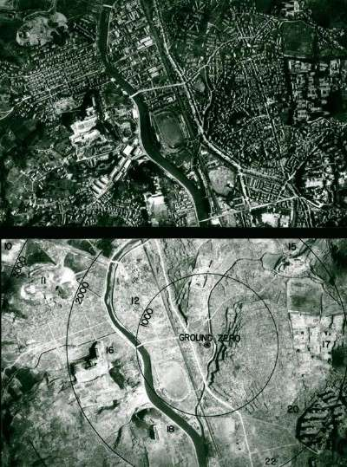

Totals : 60 – 80 million killed (2.5%)
Russia 23 million
- The first German serviceman killed in the war was killed by the Japanese (China, 1937)
- The first American serviceman killed was killed by the Russians (Finland 1940).
- 80% of Soviet males born in 1923 didn't survive World War 2
- Between 1939 and 1945 the Allies dropped 3.4 million tons of bombs, An average of about 27,700 tons of bombs each month.
- 12,000 heavy bombers were shot down in World War 2
- 3 or 4 ground men were wounded for each killed
- At the time of Pearl Harbor, the top US Navy command was called CINCUS (pronounced "sink us"), the shoulder patch of the US Army's 45th Infantry division was the swastika, and Hitler's private train was named "Amerika". All three were soon changed for PR purposes.
- When allied armies reached the Rhine, the first thing men did was pee in it. This was pretty universal from the lowest private to Winston Churchill (who made a big show of it) and Gen. Patton (who had himself photographed in the act).
- German Me-264 “Amerika” bombers were capable of bombing New York City but it wasn't worth the effort.
- A number of air crewmen died of flatulent. (ascending to 20,000 ft. in an un-pressurized aircraft causes intestinal gas to expand 300%!)
- The Russians destroyed over 500 German aircraft by ramming them in midair (they also sometimes cleared minefields by marching over them). "It takes a brave man not to be a hero in the Red Army". - Joseph Stalin
- When the US Army landed in North Africa, among the equipment brought ashore were 3 complete Coca Cola bottling plants.
- 84 German Generals were executed by Hitler
- Among the first "Germans" captured at Normandy were several Koreans. They had been forced to fight for the Japanese Army until they were captured by the Russians and forced to fight for the Russian Army until they were captured by the Germans and forced to fight for the German Army until they were capture by the US Army.

The Chernobyl meltdown was the biggest nuclear catastrophe in world history, and its effects will be felt for centuries. Radioactive wastes with half-lives lasting tens of thousands of years continue to poison the environment and affect the very genetic material of the people who must live within it.
It’s hard for the rest of the world to imagine the devastation this disaster has visited on the people, the children and the land. Because of the unprecedented scale of the accident, even scientists and subject experts can’t predict what the future holds for those who live in the shadow of Chernobyl.
The facts and figures listed below can’t capture the misery and anguish that the people of Belarus, Western Russia and Ukraine experience in the aftermath of the explosion, but they offer a sense of the incredible magnitude of the challenges these communities face.

Children
- Today in Ukraine, 6,000 children are born every year with genetic heart defects. More than 3,000 will die for lack of medical attention.
- Children born since 1986 are affected by a 200 percent increase in birth defects and a 250 percent increase in congenital birth deformities.
- 85 percent of Belarusian children are deemed to be Chernobyl victims: they carry “genetic markers” that could affect their health at any time and can be passed on to the next generation.
- UNICEF found increases in children’s disease rates, including 38 percent increase in malignant tumours, 43 percent in blood circulatory illnesses and 63 percent in disorders of the bone, muscle and connective tissue system.
- Each child living in an institution, such as an orphanage or mental asylum, is allocated just €1 per day to live.
- In 2004 nearly 26 percent of children under 17 lived below the poverty line.
- More than one million children continue to live in contaminated zones.

Health
- Seven million people living in the affected areas received the highest known exposure to radiation in the history of the atomic age.
- Belarusian doctors have identified increases in a number of cancers, including: a 200 percent increase in breast cancer, a 100 percent increase in the incidence of cancer and leukemia, and a 2,400 percent increase in the incidence of thyroid cancer.
- The mortality rates among the population already outstrip their birth rates.

Environment
- 99 percent of the land of Belarus has been contaminated to varying degrees above internationally accepted levels.
- 2,000 towns and villages were evacuated, and more than 400,000 people have been relocated from their homes since 1986. Decades later, another 70,000 are still waiting to evacuate.
- The exclusion zone, known as “Death Valley,” has been increased from 30 to 70 square kilometres. No humans will ever be able to live in it again.
- Some of the contaminants infecting the soil and air, such as plutonium, have a half-life of 24,400 years.

Economy
- The cost of the Chernobyl blast and its consequences is being carried by the survivors and will be handed down to their children for generations.
- The Chernobyl disaster costs Belarus 20 percent of its annual national budget.
- It is estimated that the fallout from the disaster will cost Belarus $235 billion.
- Five percent of Belarusian adults live on less than €2.50 a day.
- 1.7 million live in poverty, and 178,000 of these live in 'extreme poverty' (less than half of the minimum subsistence levels)
- Children are the poorest sector of the population, facing 1.5 times greater risk of poverty than the average level across the country.

Chernobyl meltdown
- The accident released radiation 200 times greater than that released by both atomic bombs dropped on Hiroshima and Nagasaki.
- 100 million curies of radiation were originally believed to have been released, although many scientists now believe it was closer to 250 million curies.
- 70 percent of the radiation fell onto the population of Belarus, affecting seven million people.
- Scientists feared that a further explosion could occur, producing a force of three to five megatons, and exposing the whole of Europe to enormous radioactive contamination.
- 800,000 men risked their lives and exposed themselves to dangerous levels of radiation to contain the situation.
- At least 25,000 of these men have died and a further 70,000 are disabled. Twenty percent of these deaths were suicides.
