30 Days Question
Directions: Answer the following in one paragraph (5 sentences)
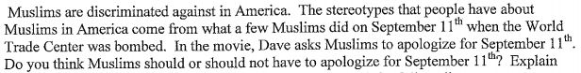

*************************************************************************************************************
18.2&3 Questions

Directions: Answer each of these questions in your own words. You do not need complete sentences.

18.2- Cultural Blending
- What are the most prominent results of cultural blending?

- What branch of Islam did the Safavid Empire align themselves with? Where were they geographically located?

- What did Shah Isma’il do to Sunni citizens in his empire? How did Selim the Grim respond in the Ottoman Empire?

- How did Shah Abbas reform the Safavid Empire in terms of government and religion?

- How did Shah Abbas’ actions while finding a successor ruin the empire?

18.3- Mughal Empire in India
- Who was the leader that founded the Mughal Empire? What was he noted for?

- Explain how Akbar was a genius at cultural blending.

- Where did the Sikh religion come from? Did the Mughal Empire like this religion?

- What is the origin of the Taj Mahal?

- What was happening to the Mughal people while Shah Jahan was spending time and money building monuments and buildings?

- How did Aurangzeb come to power? What did he do to his father, Shah Jahan?

- How did Aurangzeb treat Hindus during his rule? Be specific/

- Who did Aurangzeb give the Port of Bombay to? What did this do for the future of India?

