Cinderella Man
Viewing Guide

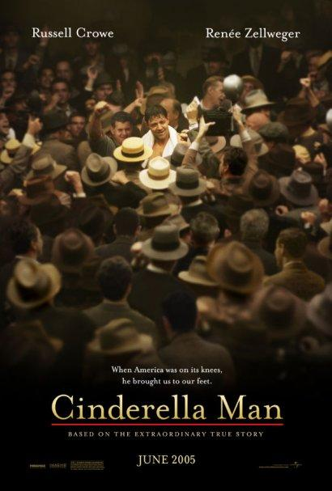

DIRECTIONS:
- Read the discussion questions before viewing.
- Based on your knowledge of the Great Depression and on what is depicted in the film, answer the discussion questions after viewing the movie.
- Submit answers to discussion questions on Google Classroom!

Cinderella Man Discussion Questions

- How do the visuals of the film and the music combine to portray the hopelessness and despair of the Great Depression?

- “Character is what you do when no one is looking.”

  - How does Jimmy’s character shape his destiny?
  - What did you think about the scene in which Jimmy has to take his son to return the salami he has stolen? What did the scene tell us about Jimmy’s character and his relationship with his son/children? What were Jimmy and Mae’s beliefs about their family, their children?

- Taking the role of a man with a family living during the Depression, explain how it feels to be out of work. Why does Jimmy give back the money he “borrowed” from the government?

- This movie was based on a true story. Explain why Jim Braddock became such a hero to the people living out the Great Depression day by day.

- What did the film mean to you? Describe how the film made you feel. Did you like the film? Why or why not?

