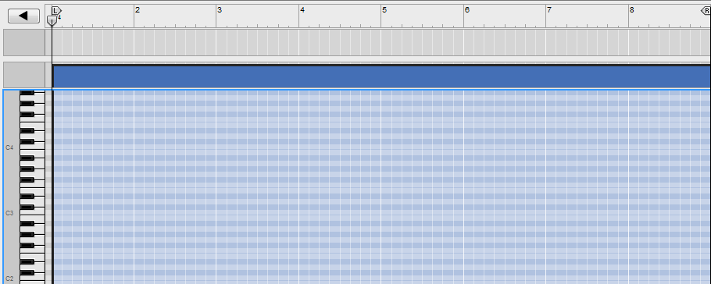
NAME: ______________________________ a minor scale activity

- Draw an a minor scale (a – b – c – d – e – f – g – a) in the piano roll view above.

- Fill in a ‘perfect 5th’ above each note in the a minor scale (ex. a – e)

- Fill in the diatonic 3rd for each of the chords in the a minor scale (ex. a – c – e )

- Determine how many half steps are between each of the notes of each chords

- Write in the roman numerals for all of the diatonic chords in the key of a minor.

- Play each of the chords using a basic piano patch

