Section 2.1 | Pg. 65: 8, 9, 13-16, 25, 26 | 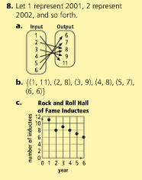
Section 2.5 | See Example problem 3 on page 95.  Pg. 96: 12 | 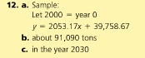
Section 2.6 | Pg. 104: 10-12, 22, 32, 33, 36, 37 | 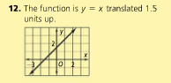  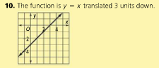  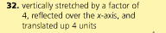  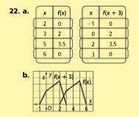
Section 2.7 | See Key Concept Box on pg. 108  Pg. 111: 1, 14, 17, 23, 24, 30 | 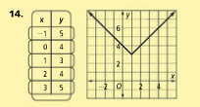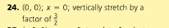
Problems you should know how to do for the 2.1, 2.5, 2.6, 2.7 Quiz!!!

