1.
Answer: 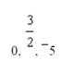

2.
Answer: 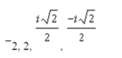

3.

Answer: 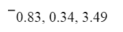

4. 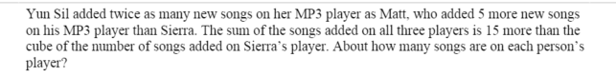
Answer: 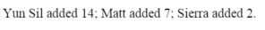

5.
Answer:

6.
Answer:

7. 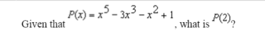
Answer:

8. Factor: x³ – 27 9. Factor: x³ + 8 10.

