Name:__________________________________________

Review for sections 3.1-3.3 Algebra II CP

**Solve each system by graphing.**

**1. ** **2. ** **3. **

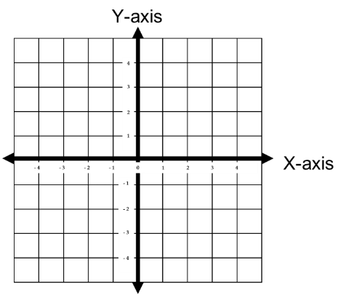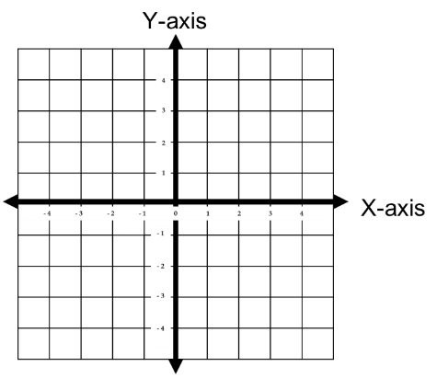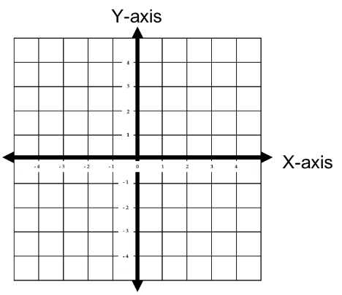

**Solve each system by substitution or elimination.**

**4. ** **5.  6. **

**Without graphing, classify each system as one solution, infinitely many solutions or no solution.**

**7.  8.  9. **

**10.**

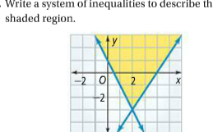

**Solve each system of inequalities by graphing**

**11.  12.  13. **



**14**

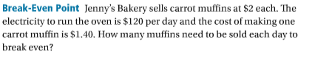

**15.**

