2017 Athletic Registration Information:
Please ensure that all forms are completed in their entirety and submitted to the appropriate places prior to our start date, Friday March 3, 2017. Please leave sufficient time for forms to be processed and approved. Players will not be permitted to practice or play until all of the required documents are completed, submitted, and cleared by the school nurses and athletic trainers. Missed practices will hurt the team and individual player. This could result in missed game time and/or other consequences.

Link to website: http://www.nhvweb.net/vhs/healthoffice/athletic-registration-information/

Each season: The following must be completed before the due dates listed on the athletics webpage in order to participate (February 28). These forms must be submitted through Aspen.
- Complete the Health History Update Questionnaire. (All athletes must complete & submit this form even for new physical exams at the start of each season.)
- Complete the Consent for Athletics Participation Form.
- Complete the “Over the Counter” (OTC) medication form, and the “Emergency Contact Information” form.
- Complete any other forms that pertain to your child, i.e. physical form if more than 365 days old, Epi-pen, inhaler, diabetes.
- In Aspen, parents can run a checklist report to see if any forms are missing in order for their child to participate.

Once a year: Hand in the completed physical when it is completed (including a vision, signed cardiac module) and ALWAYS MAKE A COPY FOR YOUR RECORDS!!
- Annual Pre-Participation Physical Exam. Form is available for download through Aspen or picked up at the health, athletic or main offices, includes:
  - Medical History with explanations of anything marked “yes”, and signed by parent and student.
  - Family Doctor’s Examination (Physical form)- Make sure it is completely filled in, including vision!
  - Clearance form with completed Cardiac Module (Note that the Cardiac Module must be signed and dated. Physicians in Pennsylvania and New York have not completed this cardiac program and are unable to sign. It is recommended that a NJ physician perform the physical exam and paperwork.)
  - Review and Approval to Participate by Voorhees District Doctor (This may take up to 48 hours)

Physical examinations can be returned to the box on the door of the health office if the nurses are not in. (Nurses have very limited hours in the summer.) They can also be faxed to 908-638-2188 or sent to the nurses’ email addresses below.
If needed for a Medical Condition, the following forms are also required for Intramural participation and need to be submitted to the Health Office:
- Diabetic Management Form
- Epinephrine-Self-Administration
- Inhaler Form
- Over the Counter Medication Administration Permission
- Scoliosis Screening Form and Waiver

There will be at least a 24 hour waiting period for athletic participation for Aspen registration or physical examinations received after the due dates.
Contact information:
Keith Skinner, ATC, Athletic Trainer kskinner@nhvweb.net, 908-638-6116 ext. 7459
Steve Syrstad, ATC, Athletic Trainer ssyrstad@nhvweb.net, 908-638-6116 ext.7458
Pat Tomczyk, RN, BSN, CSN ptomczyk@nhvweb.net 908-638-2148
Suzanne Bauer, RN, BSN, CSN sbauer@nhvweb.net 908-638-2148
Voorhees High School, 256 County Route 513, Glen Gardner, NJ 08826
Health Office Fax Number 908-638-2188

Instructions for Aspen Forms

Forms Available in Aspen
Both online and paper forms are available in Aspen.
To complete Online Athletics signup, there is a minimum of two online forms that you need to submit:
- Health History Update Form
- Consent for Athletics Participation Form
After you submit the two online forms, Aspen will tell you if there are additional paper forms that you need to submit (e.g. a new physical if your physical would expire before your sport begins, or perhaps an epipen form if your child needs one). These paper forms are available to download from Aspen from the same page where you access the online forms.

Completing the Online Forms in Aspen
Here is how you find, fill and submit the online forms to sign up your child for Athletics:
Login to Aspen and click on Page Directory under Pages
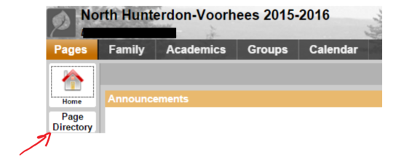

A Popup Window with icons will appear. Click on the:
- “North Sport Forms” icon if your child is enrolled at North Hunterdon High School;
OR
- “Voorhees Sport Forms” icon if your child is enrolled in Voorhees High School.
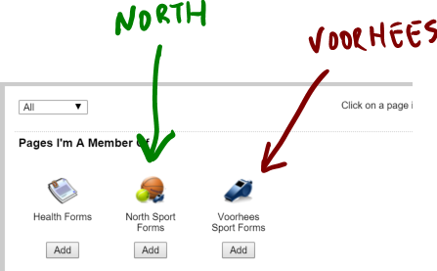

The Sport Forms page for your child school will appear. Please read this page carefully. It contains links to all forms that you might need to submit:
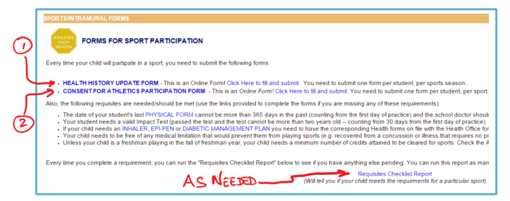
To access the Health History Update Form, either click on HEALTH HISTORY UPDATE FORM or Click Here to fill and submit.
The following screen will appear, with “NHV HSU Form” already selected next to the box Workflow. Select your student by clicking the magnifying glass and click Next. (Do NOT select a different Workflow from the “Workflow” drop down box.)
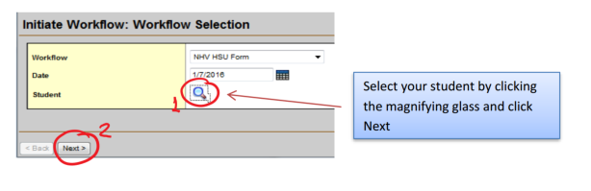
The Health History Form will pop up:
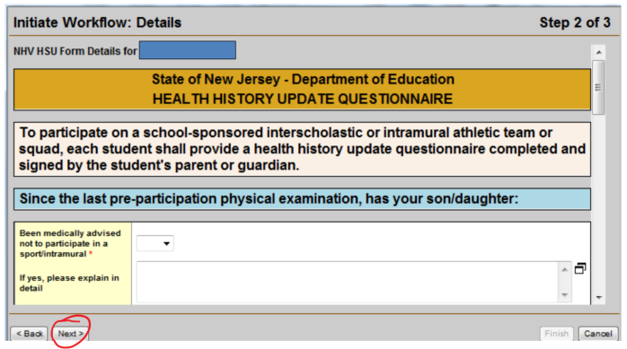
For each question with a red star (*), indicating a required field, choose an answer by clicking on the down arrow in the subsequent drop box. When you reach the bottom of the form, click Next.
Click Finish on the following screen to submit the form and receive an email confirmation
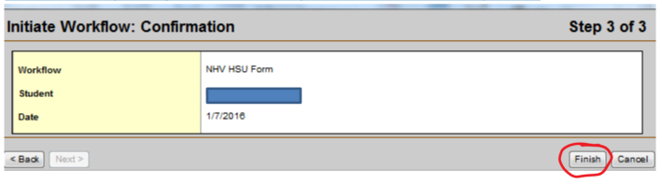
This will bring you back to your home page.
To fill in and submit the CONSENT FOR ATHLETICS PARTICIPATION FORM, you must go back to step 1 (Page Directory). At step 3, you will choose the Consent form by either clicking on Consent for Athletics Participation Form or Click Here to fill and submit. When you are done, you will receive a checklist via email, which shows which forms were received and whether the student is eligible to participate.

Notes
Note for Spring Sports: Please note that students are not eligible for spring sports when we first open for submission (early January). This is because students must have earned at least 15 credits during the first semester and the grades are not due until the end of January. However, a student or parent may run the Requisites Checklist Report at any time from the Forms for Sport Participation page.
Note for Fall Sports: Please note that if you are applying for a fall sport for NEXT school year, credits won’t be calculated until we rollover to the next school year (typically mid July). Also note that credit count might change if you are taking summer credit restoration courses and those credits won’t be counted until after credit restoration has been completed. However, a student or parent may run the Requisites Checklist Report at any time from the Forms for Sport Participation page.

Checklist Requisite Report
You can, at any time, run the “Checklist Requisites” report. It will tell you your child eligibility status to participate on a given sport.
To run the “Checklist Requisites” report, click on “Requisites Checklist Report” on the Sport Form page:
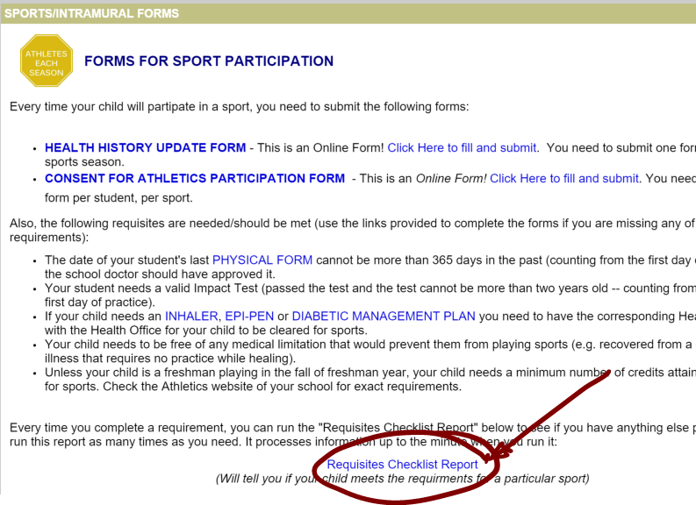
On the pop-up window that will appear, choose the student and the sport by clicking on the magnifying glasses to the right:
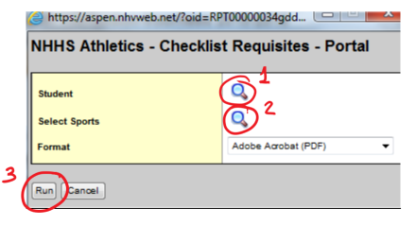
Click Run and you will see a report like this one:
