Map of Asia

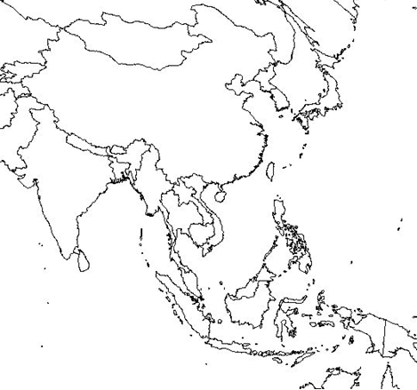

Locate and Label:
Countries/Regions | Cities | Bodies of Water
Cambodia  China  Japan  Laos  Malaysia  Region of Manchuria  Mongolia  Myanmar (Burma)  North Korea  Philippines  South Korea  Russia  Taiwan  Thailand  Vietnam | Beijing  Guangzhou  Hanoi  Hiroshima  Ho Chi Minh City  Hong Kong  Manila  Nagasaki  Nanjing  P’yongyang  Seoul  Singapore  Tokyo | Bay of Bengal  East China Sea  Indian Ocean  Pacific Ocean  Sea of Japan  South China Sea  Yellow Sea

The cities can be listed below with the countries they are located within.

