Creating a Research Question
French and Indian War Project

Each of you has been assigned a BROAD historical topic to research. Each topic has hundreds (even thousands) of books, essays, etc. written on it. So, how can a junior/senior write a quality 3-5 page essay on such a topic?
My Broad topic is: Iranian Revolution of 1979
(French and Indian War)

Example of what we are doing today….

Broad Topic | Restricted Subtopic | Research Question
Pollution | Acid Rain | What can the United States do to prevent acid rain?
Fishing | Commercial fishing | What impact do fishing regulations have on commercial fishing in New England?
Censorship | Internet | How will China’s effort to censor the Internet affect its citizens?
Nutrition | Diets | What nutritional benefits are there to vegetarianism?

1. Learn about your Broad Topic
- During this step, you need to read about your Broad topic in your text book or some form of electronic encyclopedia. Wikipedia is acceptable only during this first step. During the research process, this is the only time these sources are allowed to be used.
- wikipedia article for the French and Indian War

2. Potential Restricted Subtopics (already done for you!) EACH topic must be covered by at LEAST 2 students

Restricted Subtopics | Mods 7-8 | Mods 9-10
Origin of Name (up to 3 students student)
North America In the 1750s (up to 4 students)
Events leading up to the War (up to 4 students)
Course of the War (up to 3 students)
British campaigns (up to 3 students)
French victories (up to 3 students)
British conquest (up to 4 students)
Consequences (up to 4 students)

3. Take notes and Create ONE Power Point slide for your topic (example below)
  - Create one power point slide on the classroom power point summarizing the information for your restricted subtopic- if you have more than one student in a restricted subtopic, divide and conquer the summary BUT each student must present one slide of the TOPIC information!
  - Place the Topic Title in the title of the slide- YOUR LAST NAME
  - Use broad bullets to summarize the information in wikipedia
i. you will probably need your own notes
ii. NO more than one slide per student on the TOPIC information!
  - Use one picture that illustrates the most important information
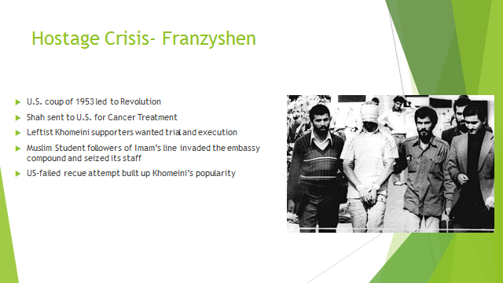

4. Research Question: Create ONE research question from ONE of the restricted subtopics that you were assigned
1. Create one power point slide for ONE source you found that gives the class more information about your topic selection- What do you want to find more information about?
1. Narrow down the research for your topic into something more specific
2. create a research question- place question into the title of the power point slide- LAST NAME
3. find one resource
4. cite that resource using noodle tools- place citation in the power point slide
5. summarize that article in the power point slide
1. AGAIN- use broad bullets summarizing the information in the article
2. You may also want your own note sheet

There are 4 questions to consider:

1. Comparison: How does the long term health of players who used steroids compare with those who did not?
2. Cause and effect questions: What effect have the steroid investigations had on baseball players’ morale?
3. Measuring questions: To what extent has the steroid use crisis impacted fans’ expectations of the players?
4. Process questions: How are players monitored for steroid use and educated about the dangers of steroid abuses?

Check to be sure that the research question meets that following criteria:

1. Is it open ended (cannot be answered with simple yes or no)?
2. Does it addresses an issue or controversy and or solves a problem?
3. Is it something you can take a stance on?

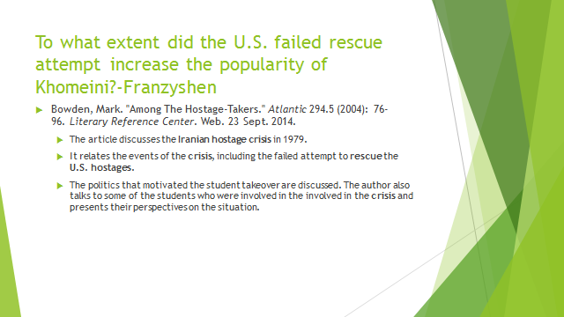

Grading

 | 5 | 4 | 3 | 0
Restricted Subtopic WIKIPEDIA SLIDE  Grading criteria  5 point scale for each of the 5 criteria=  _____/25 TOTAL POINTS | - Student summarized all the information and clearly demonstrated their knowledge of the entire restricted subtopic within the context of the BROAD topic  - Student used quality bullets and explained each in a thorough manner so the rest of the class could understand it  - Student demonstrated quality presentation skills- They did not JUST READ from the slide- made eye contact and did not just look at notes  - Student put their name on the slide and incorporated the slide in the CORRECT order of the classroom power point  - Student incorporated a meaningful picture and explained that picture to the class.
Restricted Subtopic Research question slide  ______/25 TOTAL POINTS | - Research question meets the following criteria:  - it is open ended  - it does address a controversy or a problem  - you can take a stance on it!  - Student presents a quality summary of the article and shows that that he or she actually read it!  - Student cites the document correctly using MLA format
______/ 50 TOTAL POINTS

