Chapter 25 Section 1: Italian Unification
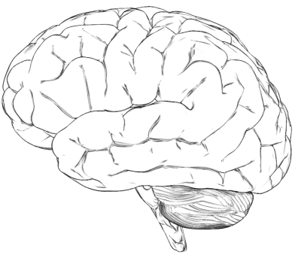
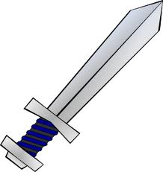

Nationalism:

Risorgiemento:

Carbonari:

Young Italy Movement:

Sardinia-
- Leaders:

- Which leader called the shots?

War with Austria:
- What was Napoleon the III’s involvement?

- Why did Cavour want to go to War with Austria?

“Expedition of the Thousand"
- Led by:
- Why did Cavour stop him?

