Ch 13 and Ch 14 The Dark Ages
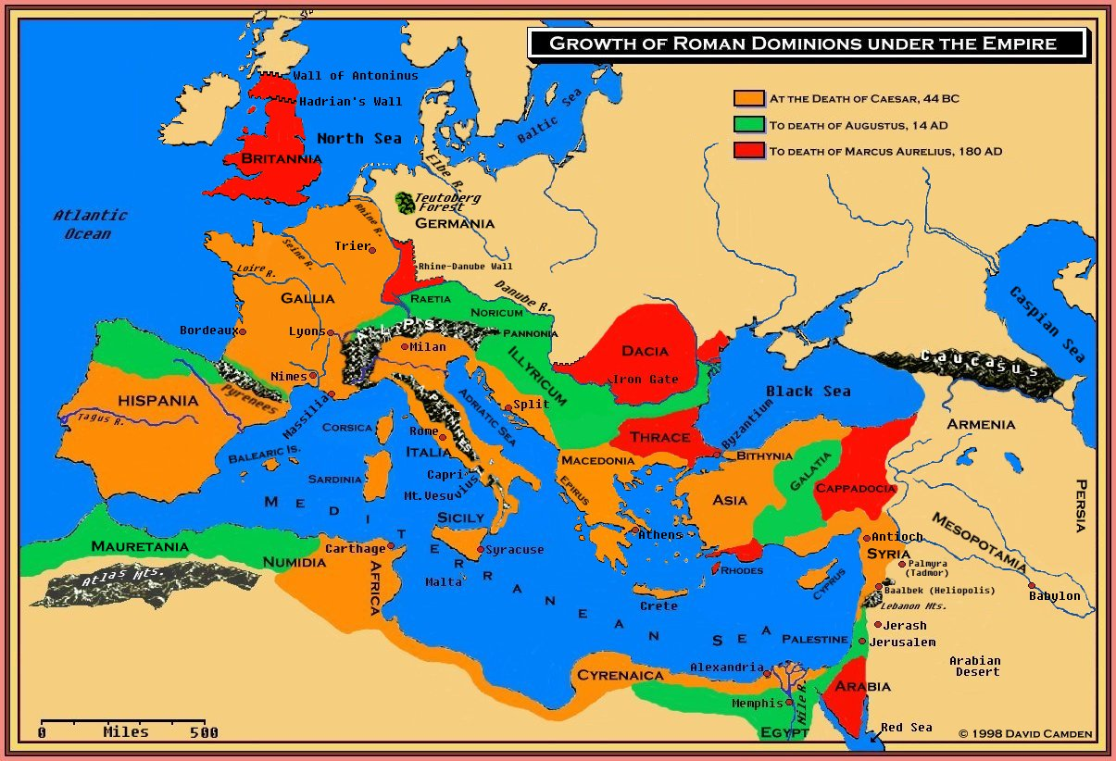

Fall of the Roman Empire Creates: instability, ____________, nonuniformity
1. No Roman _______________ for security and protection
2. Disruptive _____________________/travel/transportation
3. Law enforcer/unity/equality- social differences
4. ___________________ -power struggle/regional and local, very fragmented
Outcome of the fall of the Empire: Middle or Dark Ages

Priests – 1% of population
educated\education
Interpret the Bible
Spiritual leader of the community
Central Government – welfare state
Law
Economy
Record Keepers
Coronations – make kings bow to them
- Pope Innocent the III
http://www.youtube.com/watch?v=xkWtA4-34VE&feature=related
Administrators
Major land owners - donations
$$$$$$ - tithe, indulgences, holy relics, tax exemptions
Excommunicate – no heaven
Oath of Loyalty
Peace\Truce of God no killing Europeans, no killing noncombatant, Holy days no fighting
Conflict – Church vs. State
Church vs. Man
Benedictine Rule – monks living in monasteries followed this way of life\different than priests
Dominican Order – St. Dominic – reform the clergy\get rid of heretics and heresy peacefully
- specialized in lawyerly disputation and preaching, professors of law and theology in early universities
St. Francis of Assisi – Franciscan Order – vow of poverty and humility (reforms)
Jews – lived in separated areas from Christians in ghettos
- were the bankers because the Church was against usury
- not allowed to own land, be in guilds, or be a part of government
- pogroms – attacks on Jews, they go east, kings wants their money
Holy Roman Empire
Clovis
-Charlemagne: King of ___________________
- Germanic tribe – Franks, Saxons-Angles, Vandals, Visigoths, Ostrogoths
- Charlemagne defeated ______________________ creating an alliance with the ___________.
- Charlemagne and ____________ attempt to recreate the _______________ Empire and Christendom.
- Received the title __________________________ by the Pope
-Capital is _________________________
-Fraternal War: Treaty of _______________ (3 brothers fighting over the Holy Roman Empire)
Lombards
Pope Leo III
Divine Right
King of the Castle!!
Manors: Roman official’s hide\getaway
Manoralism - political, economic, and social system by which the peasants of medieval Europe were rendered dependent on their land and on their lord for land and protection\stability
- Self sufficient and independent institution
- Regional government
- demesne
- fallow system
- commune\domestic system
- manor court
- heredity privileges and rights: 1st born, 2nd born, 3rd born…….7 out of 10 children do not make it to adult hood!!!!
- usufruct – the right to use the land but not own, could get kicked off
Serf - person in a condition of servitude, required to render services to a lord, commonly attached to the lord's land and transferred with it from one owner to another. – SLAVE – Christianity outlawed slavery. Serf not bought or sold, human, rights and a soul, debt and/or protection, 90%
Peasant – small farmer or farm laborer – FREE
Knights started off as mercenaries. “The medieval knight was the equivalent of the modern tank…….No single foot soldier or archer could stand up to any one knight….. It was terribly expensive to be a knight. The war horse alone could cost the equivalent of a small airplane……knights began to pay "shield money" to their lord so that they wouldn't have to serve in the king's army. The money was then used to create a professional army that was paid and supported by the king. These knights often fought more for pillaging than for army wages. When they captured a city, they were allowed to ransack it, stealing goods and valuables.”
Nobility – administrators of the law and government
- thought they were special\chivalry\honor but realistically mean and evil
- Wealth based on land, wasteful lifestyle, not businessmen
- Patents of Nobility – papers to show they were of noble birth
- Duke, count, marquis, baron, and knight
Feudalism – federal level – A vassal was given land by the lord. This land was known as a fief. A noble ,2-3% of population, is a person who belongs to a hereditary class distinguished by high birth, rank, or status. Nobility depending upon rank had privileges and rights that others did not have. In exchange for the fief, the vassal would provide military service to the lord. Before land was given an individual was turned into a vassal during a commendation ceremony. The person would perform an act of homage and an oath of fealty. Homage was to come to the defense of the lord and fealty to be faithful to the lord. This was not restricted to the laity but also the clergy. The lords would levy rent\taxes on individuals to generate revenues.
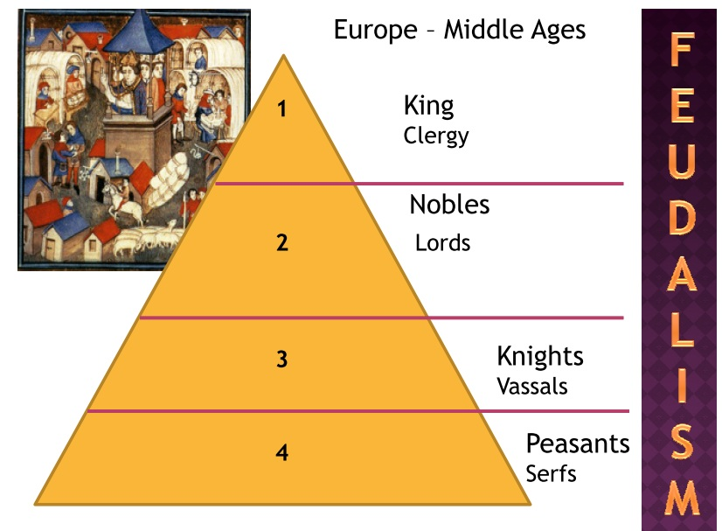
Towns\Villages – serfs\peasants escape there for freedom
- Guild system – skilled-economic and social associations of persons engaging in the same business or craft and the primary function was to establish local control over that profession or craft by setting standards of workmanship, regulating prices\ wages\working conditions, apprenticeship, preventing unfair practices, and protecting the business from competition,-monopoly- They also fulfilled many social, religious, and charitable functions.
- Semi\unskilled – hand to mouth
TRANSITION INTO THE RENAISSANCE
Corpus jurisprudence – law used to resolve conflict instead of fighting
Economics – increased stability allows, encourages, and fosters economics and professionals\entrepreneurs
- stable coinage and new financial techniques
States – definite territory with generally recognizable boundaries and a sovereignty government (supreme power). No one is superior than the government. Create stability, order, protection, and laws through elected or appointed officials.
- England William the Conquer (1066) of Normandy makes himself final source of authority, views all nobility as traitors, appoints nobles to government office shifting loyalty from king to nobility to nobility to king, Domesday Book census for taxes, royal army\treasury
- England creates a Parliament to reward local officials who were not paid to do their duties – inconsistent and many variations in regions
- France creates a royal bureaucracy of highly trained and paid officials – very uniform and organized
Towns – increased population – need things\need workers
- people purchase freedom
- new source of tax revenue for the king
- old Roman towns of significance reemerge
- Bourgeoisie – upper middle class\wealthy
- educated – lawyers, doctors, and merchants
- want to be like the nobility

- Church vs. Kings – who appoints bishops
- Pope Boniface VIII – not paying taxes\jailed
- Babylonian Captivity\Great Schism
– Pope in France Clement VII
- Pope in Rome Urban VI
- Councilar Movement – reform and resolve problems
- Wycliff
- Council of Constance – Pope\Rome
- attack heresy
- reform
Hundred Years War – England (French Nobility of Flanders) vs. France – economic war over Flanders
- England makes wool & Flanders produces wool products
- Who had the right to tax Flanders? Heredity
- Joan of Arc
- England in debt\Parliament gains power because of King’s need for taxation
- knights become obsolete because of gunpowder, cannons, long bows, common man’s infantry\cheaper
Baa baa black sheep, have you any wool?
Yes sir, yes sir, three bags full!
One for the master, one for the dame,
And one for the little boy who lives down the lane.
- England the best wool and sent it to Flanders who were better at finishing them or export tax put upon the wool going to Flanders out of British ports

