Agricultural Revolution
Fallow System
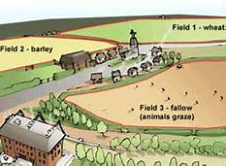

Crop Rotation
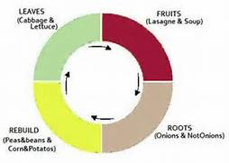
Population Explosion was due to an increase in food, better livestock, improvement in medicine, and better living conditions. This put a demand on farmers for more food. Enclosure movement was farmers buying up land and fencing it in. This puts a demand on the invention of equipment to produce more food to feed people but also to make more money. An increase in food then meant an increase in population. You need to make machines so you create factories. People move to cities to get jobs because machines were taking the farmers\peasants\serfs jobs. Job specialization causes industries to create things that people once made when they were self-sufficient. This then leads to more industry.

Textile Industry
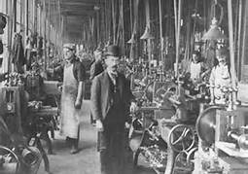
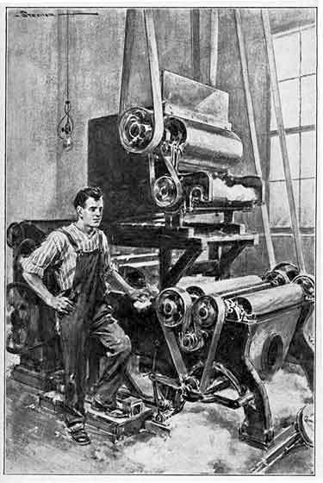

Causes of the Industrial Revolution in Great Britain
Natural Resources – (LAND) – water, coal, and iron on the British Isles, they also had colonies which had natural resources, labor force, 1\4 of the world
New Markets – places to sell their products
Geography – (LAND) – an island with many harbors to trade with theirs and others colonies, rivers to transport to and from their interior
Government – political stability, Napoleonic Wars did not touch them, favored economic growth and encouraged it, subsidies, and tariffs, low interest, excellent banking system (CAPITOL)
Entrepreneurs – (LABOR) wealthy individuals willing to take risks and individuals who had taken risks during mercantilism

\

Domestic System vs. Wage System
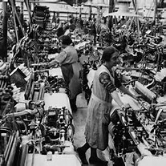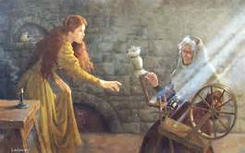
Worked at home vs. worked in a factory
Workers made their own hours vs. workers told when then would work
Worked by day light sun up to sun down vs. artificial light 24 hours
Paid by the completed product vs. paid an hourly wage
Worker completed the entire product vs. a step in the product
Expensive unique product vs. cheap mass produce products
Worker was their own boss vs. workers supervised

Outcomes
Growth in cities
Lifestyle change
Different working conditions
Middle class
Class tensions

