*i A' to.* lc'" *c·*/'\

*8 rora_c.ficC-*

1 . Starting from rest, a disk rotates with constant angular acceleration. If it takes 10 rev to reach

an angular velocity w, then how many additional revolutions are required to reach an angular velocity 2w?

a. 10 rev b. 20 rev c. 30 rev d. 40 rev e. 50 rev

2. A record turntable ro(ates through 5.0 rad in 2.8 s as it is accelerated uniformly from rest.

What is the angular velocity at the end of that time?

a. 0.60 rad/s b.. 0.90 rad/s c. 1.8 rad/s d. 3.6 rad/s e. 14 rad/s

3. You are whirling a stone on the end of a string in a horizontal circle of radius R *=* 0.65 m with a frequency of 4 rev/s when the string breaks. Just after the string breaks, the velocity of the stone is

a. straight down.

b. 32 m/s along a tangent to the circle.

c. 16 m/s along the radius away from the center. d. 1.0 m/s along the radius toward the center.

e. none of these.

4. You are pedaling a bicycle at 9.8 m/s. The radius of the wheels of the bicycle is 51.9 em. The angular velocity of rotation of the wheels is

a. 19 rad/s b. 2.5 rad/s c. 4.5 rad/s d. 3.0 rad/s e. 6.3 rad/s

5. A wheel is rotating at 30 rev/min. a. 2n2 rad/s b. *2n* rad/s

The angular velocity of the wheel is

c. 2 rad/s d. *n* /2 rad/s e. *n* rad/s

'

6. A point Pis at a distance R from the axis of rotation of a rigid body. The linear speed, centripetal acceleration, and tangential acceleration of the point can be expressed as

'

Linear Centripetal Tangential \

speed acceleration acceleration l

*i*

*!*

a. Rw Rw2 Ra

*f*

I

b. Rw Ra

Rw2

c. Rw2 Ra Rw d. Rw Rw2 Rw

e. Rw2 Ra Rw2

7. A body that moves with a constant speed in a circle

a. experiences no acceleration.

c. has no resultant force acting on it. e. is described by all of these.

b. undergoes no change in velocity. d. has no work done on it.

8. When an object is moving in a circle at constant speed, its acceleration is

a. constantly increasing. c. zero.

e. constant in both magnitude and direction.

b. constant in direction.

d. constant in magnitude.

9. A wheel rotates with a constant nonzero angular acceleration. Which of the following quantities remains constant in magnitude?

a. v, tangential velocity d. ()), angular velocity

b. a r• radial acceleration e. all of these

c. a" tangential acceleration

1 0. You give an orbiting satellite a command to rotate through an angle given by

8 = at + bt2 • ct4

where a, b, and c are constants and 8 is in radians if t is in seconds. What is the angular acceleration of this satellite at time t?

a. at b. a+ b · c c. -12 d. 2b-12ct2 e. zero

The data used to construct the graph were taken from the tachometer of

|  |  |  |  |  |  |
| --- | --- | --- | --- | --- | --- |
|  | |  | |  | |
|  |  |  | / | / |  |
|  | .... | / |  |  |  |
| / | *v* |  |  |  |  |
|  |  |  |  |  |

|  |  |
| --- | --- |
| 11. | omlad/S  80 |
|  | 60 |
|  | 40 |
|  | 20 |
|  | 0 |

an airplo.ne. The angular acceleration

durinq the 1 o s interval was

2 4 6 8 t, s

a. 3.0 rad/s2 b. 6.0 rad/s2 c. 8.0 rad/s2 d. 20 rad/s2 e. 38 rad/s2

1 2. Which of the following statements about the motion of the second hand of a clock is true?

a. The tangential velocity of the tip is constant. b. The angular velocity is zero.

c. The angular acceleration is zero. d. The radial acceleration is zero.

e. The tangential acceleration is nonzero.

1 3. A turntable has an angular velocity of 1.4 rad/s. The coefficient of static friction between the turntable and a block placed on it is 0.20. The maximum distance from the center of the turntable that the block can be placed without sliding is approximately

a. 0.50 m b. 1.0 m c. 1.4 m d. 2.0 m e. 4.4 m

1 4. A disk with a radius of 1.5 m whose moment of inertia is 34 kg · m2 is caused to rotate by a force of 160 N tangent to the circumference. The angular acceleration of the disk is approximately

a. 0.14 rad/s2 b. 0.23 rad/s2 c. 4.4 rad/s2 d. 7.1 rad/s2 e. 23 rad/s2

15. Four 50-g point masses are at the corners of a square with 20-cm sides. What is the moment of inertia of this system about an axis perpendicular to the plane of the square and passing through its center?

|  |  |  |
| --- | --- | --- |
| a. 1.0x1o·3 kg-m2 | b. 4.0x1o·3 kg-m2 | c. 2.0x1o·3 kg-m2 |
| d. 8.0 x 10·3 kg· m2 | e. 2.8 x 10·3 kg· m2 |  |

16. Water is drawn from a well in a bucket tied to the end of a rope whose other end wraps around a solid cylinder of mass 50 kg and diameter 25 em. As this cylinder is turned with a crank, the rope raises the bucket. The mass of a bucket of water is 20 kg. Someone cranks the bucket

· up and then lets go of the crank, and the bucket of water falls down to the bottom of the well. Without friction or air resistance, what is the angular acceleration of the 50-kg cylinder?

|  |  |  |
| --- | --- | --- |
| a. 1.1 x 102 radfs2 | b. 3.6 rad/s2 | c. 35 rad/s2 |
| d. 63 rad/s2 | e. 17 rad/s2 |  |

1 7. The torque exerted on a perfectly spherical orbiting communications satellite by the gravitational pull of the earth is

a. directed toward the earth.

b. directed parallel to the earth's axis and toward the north pole. c. directed parallel to the earth's axis and toward the south pole. d. directed toward the satellite.

e. zero.

18. In the figure, the rotaiional inertia of the \J.kleel and axle about the center is 12.0 kg · m2,

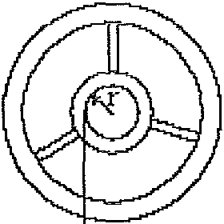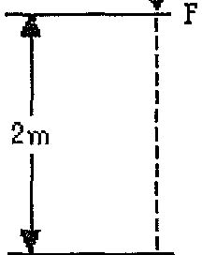

the ccinstantforce F is 39.2 N, and the radius r is o.soo m. The wheel starts from rest.

When the force has acted through 2.00 m,

the rataiional velocity *w* acquired by the wheel

due to this force will be

a. 1.26 rad/s b. 3.33 rad/s c. 3.61 rad/s d. 6.24 rad/s e. 10.3 rad/s

19. For a disk of mass M and radius R that is rolling without slipping, which is greater, its translational or its rotational kinetic energy?

a. Its translational kinetic energy is greater. c. They are equal.

e. The answer depends on the mass.

b. Its rotational kinetic energy is greater. d. The answer depends on the radius.

20.

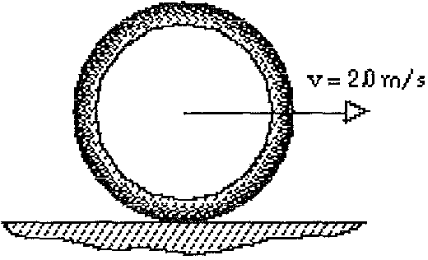

A 1.0-kg metal hoop with a radius of 0.5 m has a tmnslaiionaJ velocitl of 2.0 rnts as tt

rolls vAthout slipping. The angular momentum of this hoop about its center of mass is

a. 1.0 kg· m2/s b. 2.0 kg· m2/s c. 8.0 kg· m2/s d. 4.0 kg. m2/s e. 0.50 kg. m2/s

21. A torque is applied to a bolt by hanging a weight w from the end of the v,.,..ench,

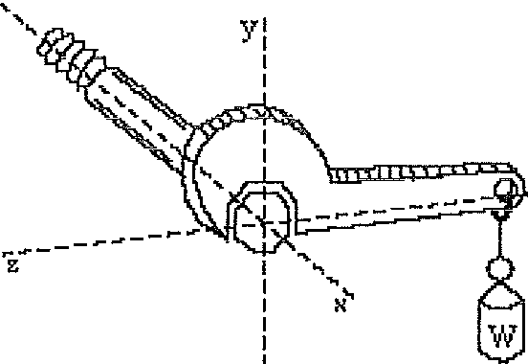

as shown. The coordinate is along wt1ich the torque vector is directed is

a. Y b. X c. -y d. -X e. z

22. z

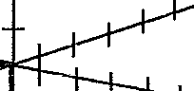

The vector C represents

y

X B

a. AxB

d. BxA

b. B ·A

e. none of these.

c. A X B

23. A disk rotates clockwise in the plane of the page. What is the direction of the angular momentum vector?

a. clockwise

c. into the page

e. Angular momentum has no direction.

b. counterclockwise d. out of the page

24. +Z

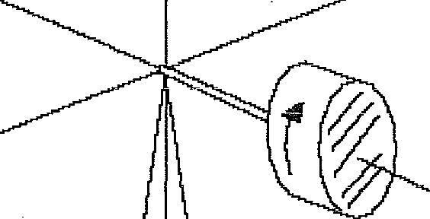

-

A gyroscopic ooeel spins clockwise as shovm. The

+y set of vectors that correctly describes the directions

of the torque., angular momentum L, and angular velocity of precession 41tp, is

-y

+N

a. T (+z); L(-x); *w* (+y)

d. T (-y); L(-z); *w* (-x)

b. T (-z); L(+x); *w* (-y)

e. T (+y); L(-x); *w* (-z)

c. T (+y); L(-x); *w* (+z)

2 5. Power can be expressed as the product of a. force and displacement.

c. torque and angular acceleration.

e. torque and angular velocity.

b. torque and angular displacement. d. force and acceleration.

26. A hoop of mass 50 kg rolls without slipping. If the center of mass of the hoop has a translational speed of 4.0 m/s, the total kinetic energy of the hoop is

a. 0.20 kJ

d. 3.9 kJ

b. 0.40 kJ

e. none of these.

c. 1.1 kJ

27.

-· .

- - .

A stone of mass 1 o kg has a rotational inertia of 2.4 kg· t"l1" about an axis A parallel to an axis through the center

of mass. If axis A is o. 20 m from

H1e center of mass axis, the rotaiional

.._ I*,/f*

. . -

inertia about the center of mass axis is

a. 0.40 kg · m2 b. 2.0 kg · m2 c. 2.4 kg· m2

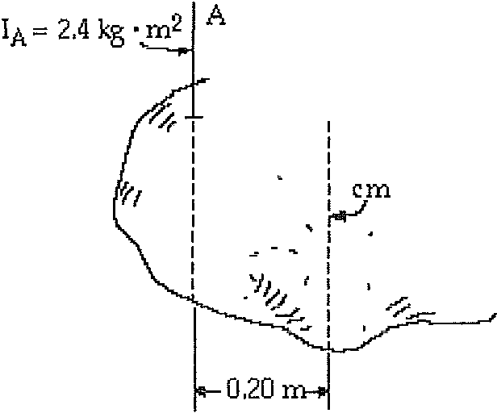

d. 2.8 kg· m2 e. 4.4 kg· m2

2 8. If the angular momentum of a system is constant, which of the following statements must be true?

a. No torque acts on any part of the system.

b. A constant torque acts on each part of the system. c. Zero net torque acts on each part of the system.

d. A constant external torque acts on the system. e. Zero net torque acts on the system.

29. A man turns with an angular velocity on a rotating table, holding two equal masses at arms' length. If he drops the two masses without moving his arms, his angular velocity

a. decreases.

b. remains the same. c. increases.

· d. increases as the angular velocity of the masses decreases.

e. decreases as the angular velocity of the masses increases.

30.

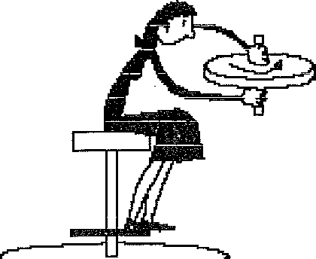

A woman sits on a stool that can turn friction­

free about its vertical ax:is. st·1e is handed

a spinning bicycle \J..otleel that has angular momentum lu and she turns tt over

(that is, through 130°). She thereby acquires an angular momentum of magnitude

a. 0

b. -1L

2 0

c. L0

d. 2L0

e. 4L0

7

