AP Physics C Newton’s Laws Practice Test

1. When Newton's first law of motion is mentioned, you should immediately think of

•

a. F net= ma b. action-and-reaction forces

c. inertia d. gravitational forces

e. centripetal acceleration.

2. Newton's Law of Inertia does not describe the behavior of objects·

a. in inertial frames of reference.

b. moving with constant velocity relative to a given frame of reference. c. at rest relative to a given frame of reference.

d. moving in accelerated frames of reference. .

e. moving in a straight line at constant speed relative to a given reference frame.

3. An Inertial reference frame is one in which

a. Newton's first law describes the behavior of matter;

b. the law of inertia is not applicable.

c. there is a great deal of matter.

d. the object of interest is traveling in a circular path. e. forces do not necessarily exist in pairs.

4. A physical quantity that is sometimes described as the measure of the resistance of a body to

a change in motion is .

a. force. b. mass. .. c. acceleration. d. weight. e. friction.

. 5. Which of the following statements includes all the essential elements of Newton's first law?

a. A body at rest persists in its state of rest unless acted on by a non-zero net external force. b. A body persists in its state of rest or of uniform motion in a straight line as long as the net

external force remains constant.

c. For every action there is an equal and opposite reaction.

d. A body persists in its state of rest or of uniform motion in a straight line unless acted on by a non-zero net external force.

e. The acceleration of a body is proportional to the net external force acting on it and to the mass of the body.

6. A net force of 64 N acts on a mass of 16 kg. The resulting acceleration is

a. 16 m/s2 b. .51 m/s2 c. 64 m/s2 d. 9.0 m/s2 e. 4.0 m/s2

7. If you apply the same force to objects with masses M and 4M, the acceleration of the mass M

is

1. The same as for mass 4M
2. Four times the acceleration of mass 4M
3. One fourth the acceleration of mass 4M
4. Twice the acceleration of mass 4M
5. One half the acceleration of mass 4M

8. An object is moving to the right at a constant speed. Which one of the following statements must be correct?

a. No forces are acting on the object.

b. A larger number of forces are acting on the object to the right than to the left.

c. The net force acting on the object is to the right

d. No net force is acting on the object

e. Just one force is acting on the object, and it is acting downward.

9. Which of the following statements is true?

a. The mass of a body is a quantitative measure of its inertia.

b. Mass is a vector quantity.

c. The mass of a body is directly proportional to the acceleration it is experiencing. d. The unit of mass in the U.S. customary system is the newton.

e. The mass of a body is inversely proportional to the resultant force acting on it.

10. An unknown force **F** is applied to two unknown masses Ma and Mb. Their accelerations aA

and B are measured. From these data we can determine

a. the magnitude of F only b. MA and MB only.

c. the magnitudes of F, MA and MB only d. the ratio of MA to MB only

e. MA, MB, and the weights of MA and MB

11 . The mass of a body that weighs 2.00 N at sea level is

a. 0.204 kg b. 2.00 kg c. 19.6 kg d. 9.80 kg e. 0.451 kg

12. The weight of an object is

a. the same as the mass of the object.

b. the quantity of matter in the object.

c. the mass of the object multiplied by the acceleration due to gravity at sea level, regardless of where the object is located. · ·

d. the result of the gravitational force acting on the object. e. the reading on a spring scale attached to the object.

13. A person of weight w is in an upward moving elevator when the cable suddenly breaks. What is the person's apparent weight immediately after the elevator starts to fall?

a. w b. greater than w c. less than w

d. 9.81w e. zero

14. The acceleration due to gravity on the moon is only about 1/6 of that on earth. An astronaut whose weight on earth is 600 N travels to the lunar surface. His mass as measured on the moon is

a. 600 kg b. 100 kg c. 61.2 kg d. 10.0 kg e. 360 kg

15. Which of the following is a unit of force?

a. m2/s2 b. kg · s2/m c. kg · m/s2 d. N ·s e. N/kg

16. The system in the figure consists of a steel ball attached by a cord to a large block of wood. If the system is dropped in a vacuum, the force on the cord is



1. Zero
2. Equal to the difference of the masses B and W
3. Equal to the difference of the weights B and W
4. Equal to the weight of B
5. Equal to the sum of the weights of B and W

17. An 80-kg man on ice skates pushes a 40-kg boy, also on skates, with a force of 100 N. The force exerted by the boy on the man is

a. 200N b.100N c. 50 N

d. 40 N e. zero unless the boy pushes back

18. A boy holds a bird in his hand. The reaction force to the normal force exerted on the bird by the boy's hand is the force of the ·

|  |  |  |  |
| --- | --- | --- | --- |
| a. earth on the bird. | b. | bird on the earth. | c. hand on the bird. |
| d. bird on the hand. | e. | earth on the hand. |  |

19. If a force F is required to extend a spring by 20 cm, what force is required to extend it by 30 cm?

a. F b. (2/3)F c. (3/2)F

d. 600F e. (3/5)F

20. If a force F is required to extend a spring a distance 5y, how far will it be extended by force

3F? .

1. 5y b. (3/5)y c. (5/3)y d. 15y e. (3/8)y

21.

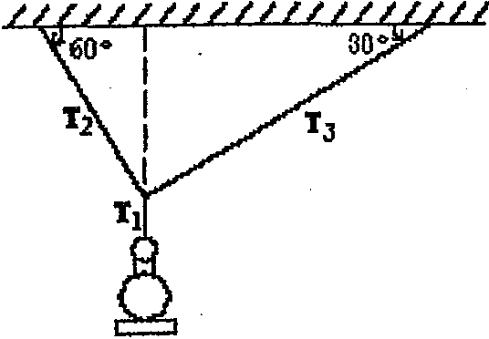

a. 210 N b. 417 N

A lamp with a mass m = 42.6 is hanging from wires as shown. The tension T 1 in the vertical wire is

c. 570 N d. 360 N e. 730 N

22. A vertical rope is attached to an object that has a mass of 40.0 kg and is at rest. The tension in the rope needed to give the object an upward speed of 3.50 m/s in 0.700s is

a. 592 N b. 390 N c. 200 N d. 980 N e. 720 N

23. 

A mass 2m is attached by a string to another mass m as illustrated. A force of N Newtons acts on mass m to accelerate the system. The force F in the string, which acts on mass 2m, is

1. (2/3) N b. N c. 2 N d. 3 N e. (3/2) N

24. A particle of mass 1.3 kg is sliding down a frictionless slope inclined at 300 to the horizontal.

The acceleration of the particle down the slope is

a. 1.3 m/s2 b. 9.8 m/s2 c. 0.5 m/s2 d. 8.5 m/s2 e. 4.9 m/s2

25. You want to elope by sliding down a nylon rope made by tying stockings together. The rope will withstand a maximum tension of 300 N without breaking. Your mass is 61.2 kg. The magnitude of the smallest acceleration a with which you can slide down the rope is

a. 9.81 m/s2 b. 4.91 m/s2 c. zero d. 2.40 m/s2 e. 19.6 m/s2

26. An object with a mass M = 250 g is on a plane inclined at 30° above the horizontal and is attached by a string to a mass m = 150 g. There is no friction and mass m hangs freely and is initially at rest. When mass m has descended a distance h= 10cm, its speed will be

a. 35.0 cm/s b. 7.00 cm/s c. 140 cm/s d. 110 cm/s e. 70.0 cm/s

4

27. Three forces X, Y and Z act on a mass of 4.2 kg. The forces are

X=2.0 N acting to the east

Y=5.0 N acting 450 to the north of east

Z=4.0 N acting 300 to the north of west

The magnitude of the net acceleration of the mass is

1. 2.9 m/s2 b. 5.3 m/s2 c. 1.4 m/s2 d. 0 m/s2 e. 18 m/s2

28. Three forces X, Y and Z act on a mass of 4.2 kg. The forces are

X=2.0 N acting to the east

Y=5.0 N acting 450 to the north of east

Z=4.0 N acting 300 to the north of west

The direction of the net acceleration of the mass

1. Cannot be determined because the acceleration is zero
2. Is 60o North of East
3. Is 70o North of East
4. Is 51o North of East
5. Is 44o North of East

29. Your heart pumps 80 g of blood with each beat. The blood starts from rest and reaches a speed of 0.60 m/s in the aorta. If each beat takes 0.16 s, the average force exerted on the blood is

a. 3.0" 102 N b. 0.22 N c. 0.16 N d. 0.30 N e. 0.98 N

30. A 15-kg block sitting on a smooth table is connected to a free-hanging 5-kg mass by a stretchless, massless cord that passes over a small frictionless pulley. The acceleration of the two-block system is

|  |  |  |
| --- | --- | --- |
| a. equal to g. | b. half of g. | c. one-third of g. |
| d. one-quarter of g. | e. zero. |  |

31. A net force is exerted on an object toward the north. The object

a. is moving toward the north. b. is moving toward the east.

c. is moving toward the west. d. is moving toward the south.

e. may be moving in any direction.

5

32. The word "normal," as it applies to forces, means

a. usual.

b. mean

c. average.

d. perpendicular.

e. straight up, in the direction opposite to the force of gravity.

33. A particle has a mass of 6.0 x 10-6 kg and a velocity of 800 m/s along the x axis when a force of 14.4 x 10-5 N along the y axis acts on the particle at right angles to its velocity. The acceleration of the particle is

a. 24 m/s2 along the x axis.

b. zero.

c. Impossible to determine; forces never act at right angles to velocities.

d. 24 m/s2 along the y axis.

e. tangential.

34. Which of the following free-body diagrams represents the

Car going uphill at a constant speed?

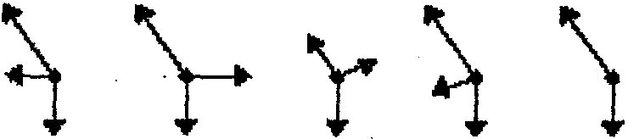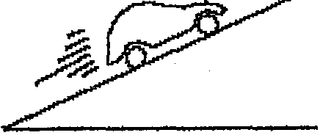

|  |  |  |  |  |  |  |  |  |  |
| --- | --- | --- | --- | --- | --- | --- | --- | --- | --- |
|  | | | | (1) | (2) |  | (3) | (4) | (5) |
| a. | 1 | b. 2 | c. 3 |  | d. | 4 |  | e. 5 |  |

35. Two groups of five men each are engaged in a tug-of-war, each man pulling with a force of 900 N. If the rope does not move, the tension in it is

a. 18 kN b. 9.0 kN c. 44 kN d. 4.5 kN e. 0.46 kN

6