Name_______________
Temperature, Heat and Expansion (Chapter 21)
Temperature-The quantity that tells how hot or cold something is compared to a standard.
-Indicates the average ____________ _________________ of an object (due to ____________ _______________ of the object
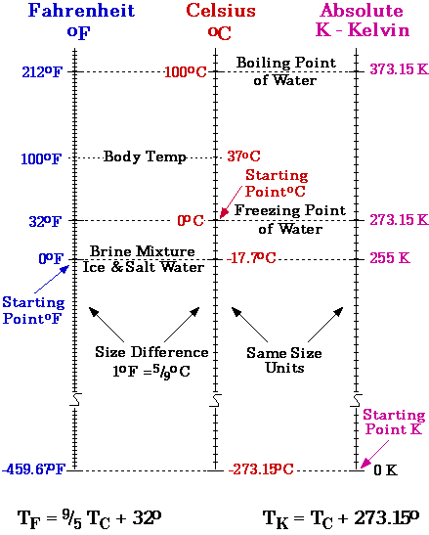
-depends on the ______________ amount of _________ per ______________, not the total
Ex. A bucket of warm water has _________ internal energy than a cup of hot water
Internal Energy-The grand total of all energies inside a substance
-depends on __________, ______________, and the ________________
-can be increased by tapping other ___________ _______________.
-____________ and ____________ may increase internal energy by exerting a force to do mechanical ___________________
Examples 1. Rub hands together for warmth
2. Strike an iron surface with great force and red hot sparks are created.
Specific Heat Capacity- the ____________ ____________ required to raise one gram of a material by one _____________ of _______________
Examples 1. Why does a piece of watermelon stay cool for a longer time than sandwiches do when both are removed from a cooler on a hot day?
2. Why is it that the climate in the desert is so hot during the day yet so cold at night?

Thermal Expansion:-
Due to _________________________ ______________________, most materials
_____________ as temperature increases.

________________ is the exception. It contracts as it ______________ until ____________,

Then it _________________ as it cools to __________________.

Examples:

