Name____________________
Chapter 6 Projectiles
- A ______________ is any object that moves through space where the only ___________ acting on the object is ______________.
- The path that a ____________ follows is called a ____________________.
  - ______________ combine ________________ motion and ________________ motion.

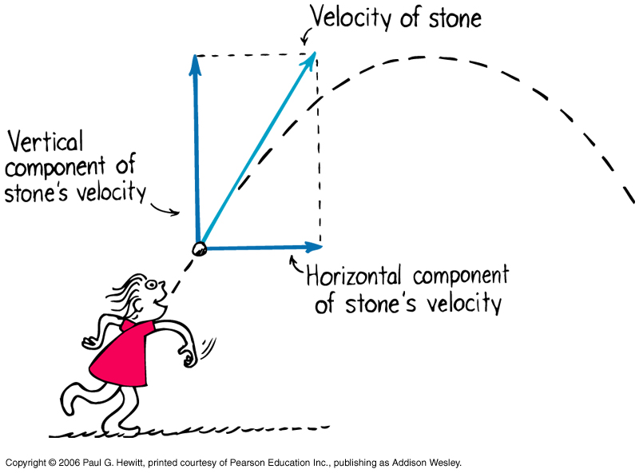
*_______________ motion combines uniform horizontal motion (______________ _____________) with freefall vertical motion ( _____________ ________________)*
Rolling ball (with no _________) is an example of __________ _____________.
_________________ of the ball is _______________ so _______________ between “frames” (equal time between frames) is ________________. Sketch the diagram below.

_______________ is an example of _______________ motion
_______________ distance from point of release ___________ in the ratios 1:4:9:16:25:… or ________…

____________ between frames increases as ________________….

*At the instant a cannon fires a cannonball horizontally over a level range, another cannonball held at the side of the cannon is released and drops to the ground.
Which strikes the ground first? *

