Name___________________________________

Chapter 4 Notes

**Eureka**

1. What does it take to overcome inertia?
2. Force varies with __________________ and change of _______________.
3. Why do you exert a force of zero at top speed?
4. What is the other physics word for rate of change of speed?
5. How fast is 36 kilometers per hour in meters per second?
6. How is acceleration measured?
7. Do falling objects accelerate?
8. What is the rate of acceleration of falling objects?
9. Give an example of something that weighs 1 newton.
10. What is weight?
11. Why do things weigh less on the moon?
12. List 2 ways to lose weight.

**Forces Cause Acceleration**

From Newton’s First law, zero force implies ________________ _______________.

Therefore, if the net force is **NOT** zero, the ______________ is not __________________ and the object _______________________

Net Force: The ____________________ of all ________________ that act on an object

The_______________ of an object is directly related to the _______ -___________ on an object and is in the ______________ ___________________

The _________________ the _________________ the _________________ the ____________.



Acceleration is directly proportional force means that if you

1. ____________ the force you _______________ the acceleration
2. ____________ the force you _______________ the acceleration
3. ____________ the force you _______________ the acceleration

Check yourself: If you push a crate with 100 Newtons of force and there is 100 Newtons of friction, does the crate accelerate? ___________ Does that mean that the crate is not moving? ________ What does it mean?__________________________________________

Now you push with 150 Newtons of force and the friction force is still 100 Newtons. Does the crate accelerate?_____________ What if a friend also supplied 150 Newtons of force? What would happen to the acceleration?__________________________

The ______________ the _______________, the less it __________________ when acted on by a _______________.

**Mass Resists Acceleration**

_________________ is **inversely** proportional to _________________

**Inversely:**  The values change in _________________ directions

As mass ________________, acceleration ________________ for a given force

As mass ________________, acceleration ________________ for a given force

Acceleration is inversely proportional to mass means that if you

a ____________ the mass you _______________ the acceleration

b____________ the mass you _______________ the acceleration

c____________ the mass you _______________ the acceleration

Check Yourself

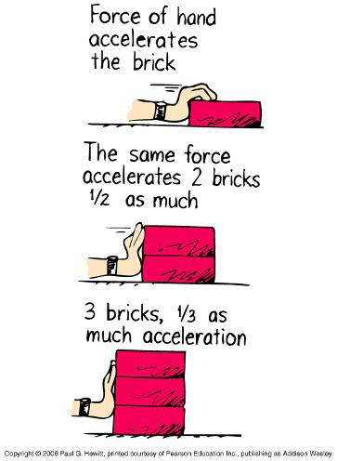 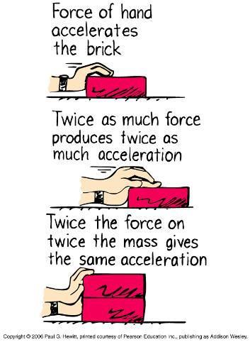

**Newton’s Second Law of Motion**

Also called the _________ ____ ___________________________

*The _____________________ produced by a net force on an object is ____________ _____________ to the magnitude of the _______ __________, is in the same ______________ as the net force, and ______________ _________________ to the ___________ of the body.

EQUATION

Acceleration goes as ________ ________________

Acceleration goes as _____________ of ________________

Acceleration is in the _________________ of __________ ________________

**Weight**

From the last section, weight was the force of gravity acting on an object. On earth, since the acceleration due to gravity is ___________________, the equation for weight is

Newton’s Third Law-

* Interactions Produce __________________
  + Forces occur in ____________-they are part of an **_______________**
    - **______________**-a mutual action
    - For example-Consider a hammer striking a nail.
    - The hammer imparts a ___________ on the nail, driving it into the wood.
    - The nail imparts ____________ on the hammer, stopping the motion of the hammer.
    - The forces are _________________
* **Newton’s Third law** states that
  + Whenever one object exerts a _________ on a second object, the second object exerts an ____________ and ________________ force on the first.

or

* + For every _____________, there is an equal and opposite ______________
* Simple recipe for treating forces
  + Object ___________ a ___________ on object B
  + Object B ___________ a__________ on object A
    - Car exerts a force on tree
    - Tree exerts an equal but opposite force on the car

A 2 ton car, going 60 m.p.h. hits a 5 ton truck, going 20 m.p.h..

The force of impact is greatest on which vehicle, the car or the truck?

The change in velocity (the acceleration) is greatest for which vehicle?

By what principle of physics?



Skydiving example C:\Documents and Settings\rquinn\Local Settings\Temporary Internet Files\Content.IE5\N1BM8UM1\MCj04360510000[1].wmf

* Action-The earth is pulling down on the skydivers
* Reaction-The skydivers are pulling up on the earth

So why doesn’t the earth move?

Answer-The earth **DOES** fall up toward the skydivers. However, the earth is MUCH MUCH larger than the skydivers so the acceleration is MUCH MUCH less

* + From Newton’s second law, the acceleration is equal to the force divided by the mass or

A=F/M

Skydiver’s Acceleration

Force/small mass=large acceleration

Earth’s Acceleration

Force/Large mass=small acceleration

Even though the same force acts on both objects, the acceleration of the earth is much smaller because its mass is so much bigger