Name______________________ Date________________________
Friction Notes:
Weight: The force of _______________ acting on an object.
Since F=MA and weight is a _____________
F_{g}=mg where g= the ________________ due to _______________
On earth g=____________________
Friction and Air Resistance are forces that ________________ motion.
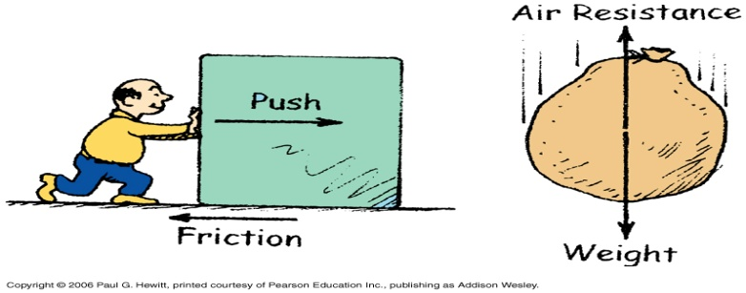
Friction:
Origin of friction is _____________ ____________ between solid _______________.
Depends on _________ force (also called __________ force) and on properties of the surface.

Depends on the ____________ of the surfaces that are moving over each other and the __________ ________ between the objects
  - __________ of __________ (μ) is a dimensionless ratio that relates the __________ of the surfaces
  - _________ force=support force. We will only be dealing with flat surfaces so Fn=weight=__________

Free Body Diagram
- A free body diagram outlines all of the _________ that act on an _________
  - Fa=__________ ___________
  - Ff=___________ ___________
  - Fn=__________ ___________
  - Fg=________
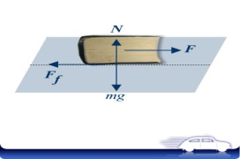
What does each force mean?
- Fa=_________ force. The _________ force that is being exerted on the object in order to make it __________.
- Ff=_________ force. The retarding force that _________ the _______ of the object.
- Fg=___________. Force of __________ on the object.
- Fn=__________ Force. The _________ _________ force the ____________ exerts on the moving object.

For friction problems, you will have to use the following equations:
- Fn=m*g
- Ff=μ*Fn
- Fnet=Fa-Ff
- Fnet=M*A

