AP Chemistry
Dr. Wilhelm
Chapter Seven Reading Guide: The Structure of Atoms and Periodic Trends

On a separate piece of paper, write a response to the following reading prompts while reviewing chapter seven of your textbook.
Electron Configuration

- The introductory paragraph of this chapter relates the ideas of electromagnetic radiation and quantum mechanics to two primary objectives. What are these objectives?

- What is the Pauli exclusion principle? How do we describe this using orbital diagrams?

- Explain now the relationship 2n² describes the maximum number of electrons in an energy shell (Table 7.1 may help with this explanation)

- What is the Aufbau principle and how does it apply to assigning electron configuration?

- Figures 7.1a and 7.1b are useful diagrams that explain the relationship of the quantum number assignment and filling order. Using Figure 7.1b as a guide, document the order in which electrons fill the energy levels (start with 1s and follow the arrows).

- Define effective nuclear charge (Z*). Understanding this will help us understand periodic trends. Don’t worry so much about how this factor is calculated but gain an appreciation of what this is describing.

- Using the filling order identified in question #5, see if you can recognize how this matches the organization of periods and blocks (s,p,d &f) in figure 7.3. Explain how the two are connected and how the organization of the periodic table supports electron configuration and the Aufbau principle.

- Briefly review the electron configuration for elements according to how they are grouped.

- What are the main group elements?

- Example 7.3 is a useful review of electron configuration. Look through this carefully then confirm your understanding by completing the review & check for section 7.3..

- When describing electron configuration of ions, where do the electrons get removed from? Explain how this applies to the transition metals. Give an example of the electron configuration for a transition metal.

- Complete review & check section 7.4. You will be responsible for understanding this.

Periodic trends:

- Identify the valence electron configuration for elements as described in the chart shown below. Use “n” to distinguish the principal quantum number and write the configuration with noble gas notation. For example group 1 = ns¹

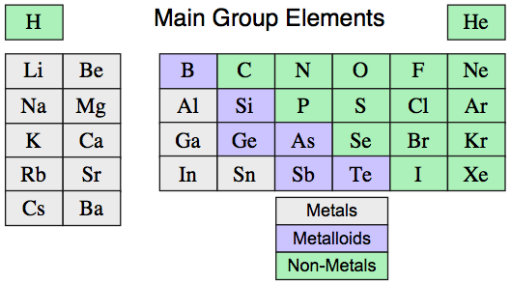

- What groups of elements are included in the main group elements?

- The books states that, “similarities in properties of the elements are the result of similar valence shell electron configuration”. Support this statement by viewing the main group elements and the valence electron configurations you wrote for question #13.

- Define atomic radius and identify the period and group trends for atomic radius. What factors influence this trend?

- Define the term ionization energy and document the equation used to describe this process. What are the group and period trends for ionization energy and what factors effect this trend?

- Define the term electron affinity and document the equation used to describe this process. What are the group and period trends for ionization energy and what factors effect this trend?

- Explain the trends associated with the size of ions. Why are cations smaller than their parent atoms and anions larger?

- What is an isoelectronic series? What is the trend of atomic size for ions in an isoelectronic series?

- Complete review & check for section 7.5.

Periodic Trends and Chemical Properties

- Section 7.6 summarizes the relationship of periodic trends and chemical properties. The relationship of these concepts allows us the ability to predict chemical reactivity and why/how compounds are formed. After reading this section, complete the review & check for section 7.6. Does this fill in some gaps to your understanding of chemical formula writing?

