Topic 15:

Normal Distributions

OVERVIEW

You began studying randomness and probability in the previous topic. Toward the end of that topic you saw that a mound-shaped distribution described the outcomes of a particular variable, such as counts and proportions. Such a pattern arises often enough that it has been very extensively studied mathematically. In this topic you will investigate mathematical models known as normal distributions, which describe this pattern of variation very accurately. You will learn how to use normal distributions to calculate probabilities of interest in a variety of contexts.

OBJECTIVES

- To become familiar with the idea of using normal curves as mathematical models for approximating certain distributions.

- To discover how to use a table of standard normal probabilities to perform calculations pertaining to any normal distribution.

- To learn how to use your calculator to calculate probabilities from a normal distribution.

- To assess the usefulness of a normal model by comparing its predictions to observed data.

- To develop an intuitive sense for how normal distributions relate to the questions of statistical inference.

- To acquire familiarity with judging what type of population a sample may have come from.
Activity 15-1: Placement Scores and Hospital Births

The following histograms display the distributions of the placement exam scores from Activity 3-8 and the simulated hospital births from Activity 14-5.
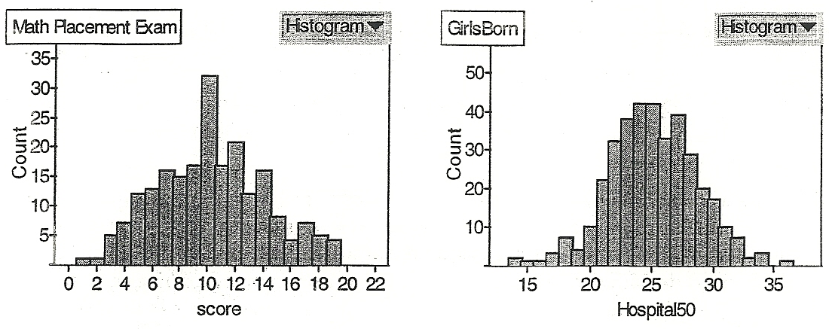

- What do you notice about the shapes of these distributions?

- Draw a sketch of a smooth curve (“smooth” meaning having no breaks or jagged edges) that seems to approximate the general shape apparent in the two histograms above.

Data that display the general shape seen in the examples above occur very frequently. Theoretical mathematical models used to approximate such distributions are called normal distributions. Every normal distribution shares three distinguishing characteristics. All are symmetric, have a single peak at their center, and follow a bell-shaped curve. Two things distinguish one normal distribution from another: the mean and its standard deviation. The mean  determines where its center is; the peak of a normal curve occurs at its mean, which is also its point of symmetry. The standard deviation 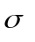indicates how spread out the distribution is.

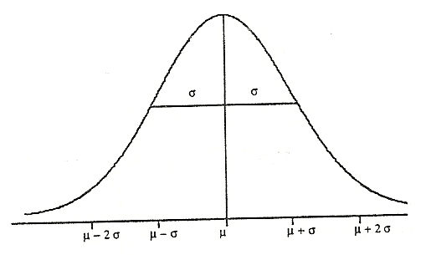
[Note: We reserve the symbols and s to refer to the mean and standard deviation computed from sample data.] The distance between the mean and the points where the curvature changes is equal to the standard deviation . The following sketch displays this relationship:

- The sketch below contains three normal curves; think of them as approximating the distribution of exam scores for three different classes. One (call it A) has a mean of 70 and a standard deviation of 5; another (call it B) has a mean of 70 and a standard deviation of 10; the third (call it C) has a mean of 50 and a standard deviation of 10. Identify which is which by labeling each curve with its appropriate letter.
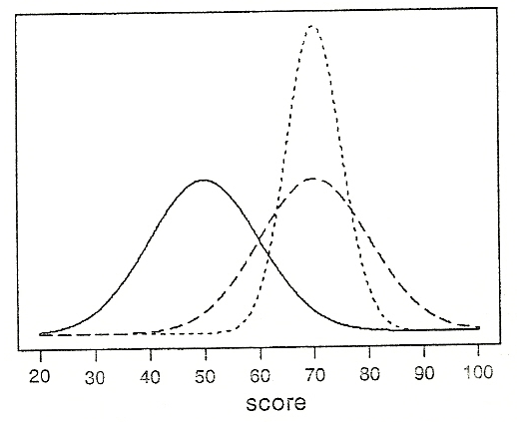

As a consequence of sharing a common shape, the placement scores and simulated births share other features such as the Empirical Rule discussed in Topic 5. The following table reports the proportions of observations falling within one, two and three standard deviations of the mean for each data set.
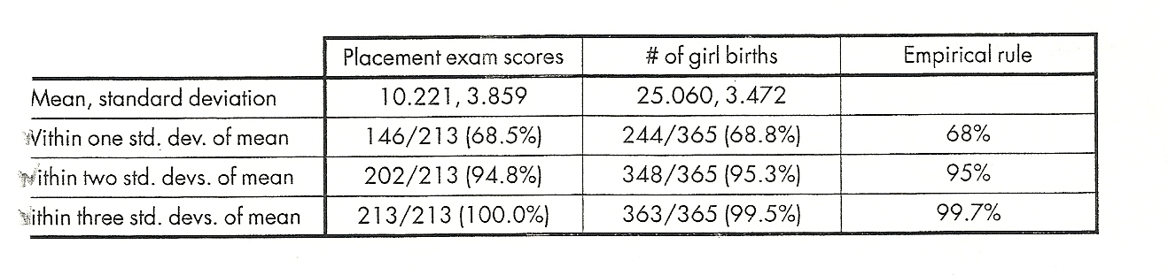

- How close are these proportions to each other and to the proportions reported by the Empirical Rule?

Recall from Topic 5 the idea of standardization to produce a z-score, which indicated a value’s relative position in the data set.

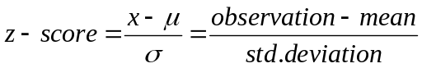

- Find the z-score for the value 8.5 in the distribution of placement exams with = 10.221 and = 3.859.

- Find the z-score for the value 23.5 in the distribution of the number of girl births = 25.060 and = 3.472.

- What is true about these two z-scores?

- How would you interpret these z-scores?

The probability of a randomly selected observation falling in a certain interval is equivalent to the proportion of the population’s observations falling in that interval. Since the total area under the curve of a normal distribution is 1, this probability can be calculated by finding the area under the normal curve for that interval.
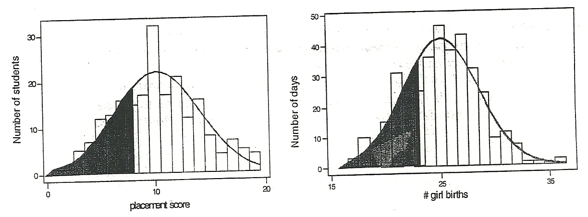

To find areas under any normal distribution, you can either use your calculator or tables. We will use Z to denote the standard normal distribution and will consider 3 cases:

- P(a < Z < b) is the area under the standard normal curve between a and b.
- P(Z < a) is the area under the standard normal curve left of a.
- P(Z > a) is the area under the standard normal curve right of a.

Activity 15-2: Birth Weights

Birth weights of babies in the United States can be modeled by a normal distribution with mean 3250 grams and standard deviation 550 grams. Those weighing less than 2500 grams are considered to be of low birth weight.

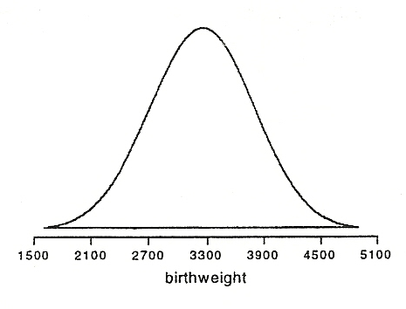
a) A sketch of this normal distribution appears below. Shade in the region whose area corresponds to the probability that a baby will have a low birth weight.

b) Based on this shaded region (remembering that the total area under the normal curve is 1), make an educated guess as to the proportion of babies born with a low birth weight.

c) Calculate the z-score for a birth weight of 2500 grams.

d) Look up this z-score in Table II to determine the proportion of babies born with a low birth weight.

e) You can also use your calculator to find the proportion of observations below a particular value in a normal distribution:
- Hit [2nd] [VARS] and select the command normalcdf(
- The command syntax is
normalcdf(lower limit, upper limit, mean, std. deviation).

For this problem enter, normalcdf(-1EE99, 2500, 3250, 550). How does this answer compare to your answer in part d?

[Notes: -1EE99 represents a very small number and is used when there is no lower limit.
1EE99 represents a very large number and is used when there is no upper limit. Lastly, if you do not specify a mean and standard deviation, they are assumed to be 0 and 1, respectively (the standard normal distribution.)]

f) What proportion of babies would the normal distribution predict as weighing more than 10 pounds (4536 grams) at birth? Always start with a sketch of the normal curve and shade the area of interest.

g) Determine the probability that a randomly selected baby weighs between 3000 and 4000 grams at birth.

h) How little would a baby have to weigh to be among the lightest 2.5% of all newborns? [On Table II, find the z-score that corresponds to a value of 0.025 and then use the z-score formula. On the calculator use the command invNorm(area, mean, standard deviation), where the area is the area under the normal distribution to the left of the “cutoff” value.]

i) How much would a baby have to weigh to be among the heaviest 10% of all newborns? [Hint: 90% of babies would weigh less than this baby.]

Activity 15-3: Matching Samples to Density Curves

While normal distributions are the most common, they are not the only kind of theoretical probability model. Any curve under which the total area is one and for which areas correspond to probabilities represents a probability model. Such curves are called density curves.

The following graphs show four very different density curves that could model a population of exam scores:
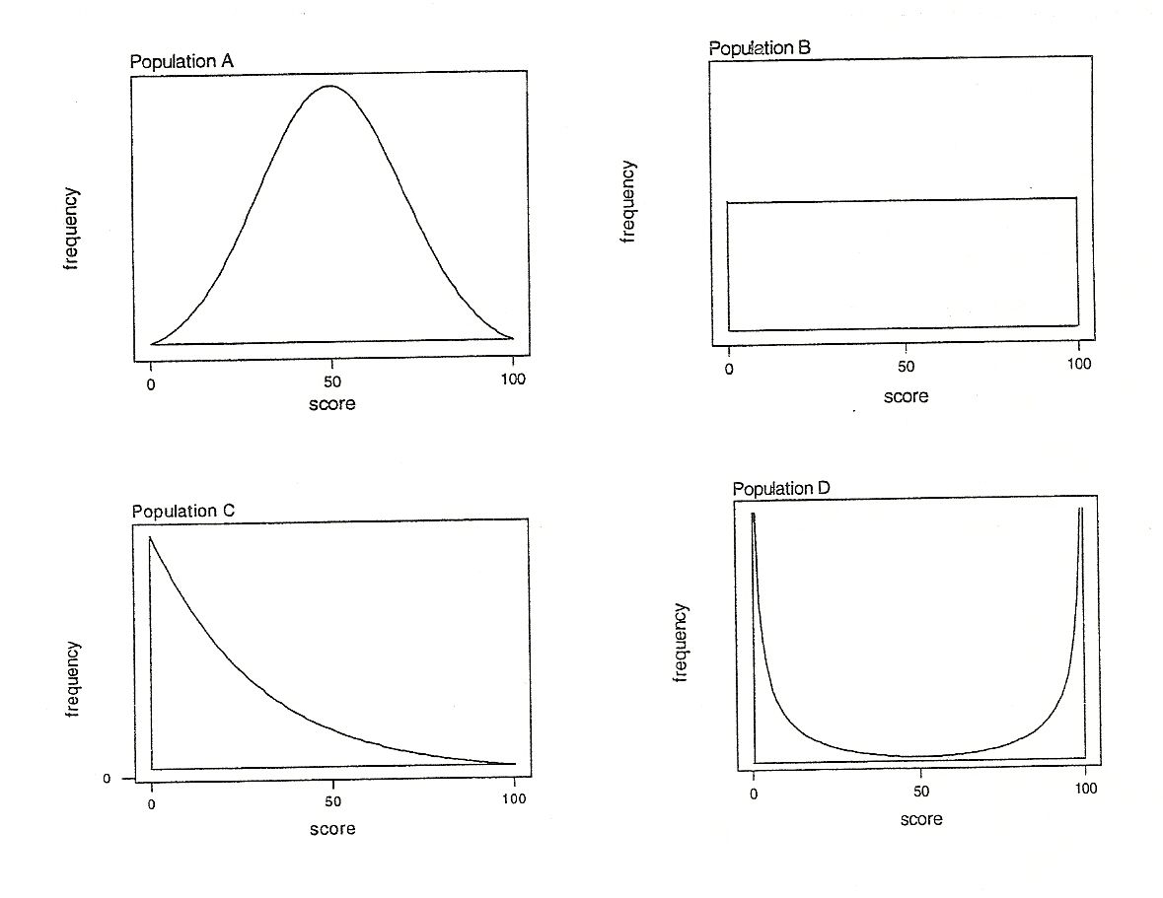

a) The following four dotplots display random samples of size 100 from these populations. Your task is to match up each sample with the population from which it was drawn.
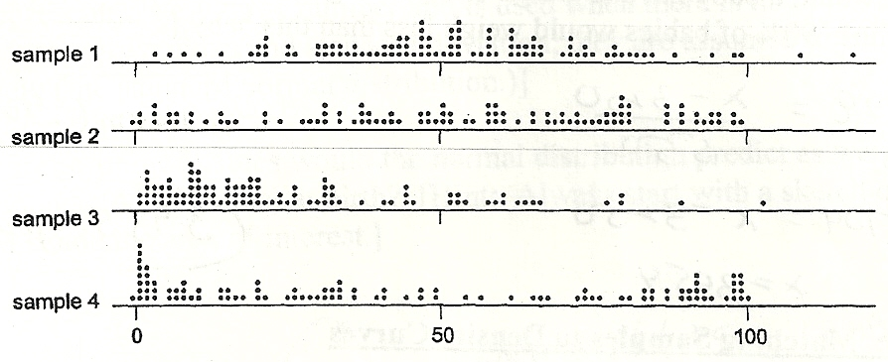
Population

Population

Population

Population

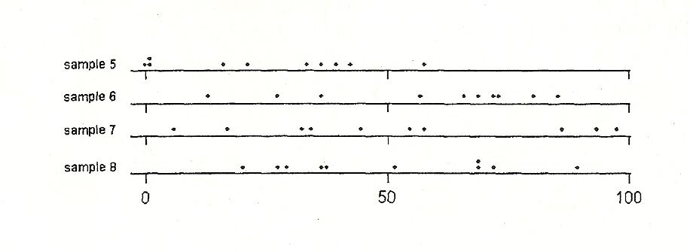
b) The following four dotplots display random samples of size 10 from these populations. Your task again is to match up each sample with the population from which it was drawn.

Population

Population

Population

Population

c) With which sample size is it easier to discern the shape of the population from which the sample was drawn?

Especially with small sample sizes, sample data from normal distributions may not look very normal and may be hard to distinguish from sample data from other-shaped distributions.

Activity 15-4: Normal Curves

For each of the following normal curves, identify (as accurately as you can from the graph) the mean and standard deviation of the distribution.
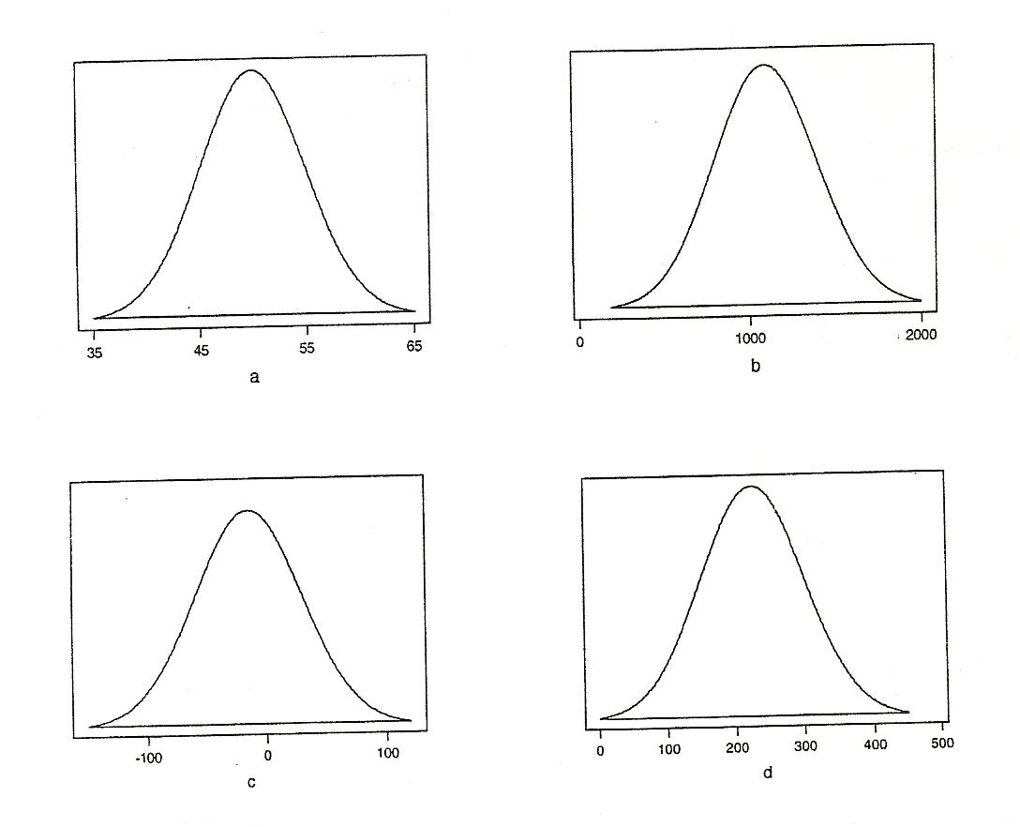

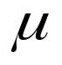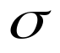

Activity 15-5: Pregnancy Durations

Data from the National Vital Statistic Report reveal that the distribution of the duration of human pregnancies (i.e., the number of days between conception and birth) is approximately normal with mean = 270 and standard deviation = 15. Use this normal model to determine the proportion of all pregnancies that come to term in:

- less than 244 days (about 8 months)

- more than 275 days (about 9 months)

- over 300 days

- between 260 and 280 days

Activity 15-8: IQ Scores

Suppose that the IQ scores of students at a certain college follow a normal distribution with mean 115 and standard deviation 12.
- Draw a sketch of this distribution. Be sure to put some labels along the axes.

- Shade in the area corresponding to the proportion of students with an IQ below 100. Based on this shaded region, make and educated guess as to this proportion.

- Use the normal distribution to determine the proportion of students with an IQ score below 100.

- Find the proportion of these undergraduates having IQs greater than 130.

- Find the proportion of these undergraduates having IQs between 110 and 130.

- Determine how high one’s IQ must be to be in the top 1% of all IQs at this college.

Activity 15-9: Candy Bar Weights

Suppose that the wrapper of a certain candy bar lists its weight as 2.13 ounces. Naturally, the weights of individual bars vary somewhat. Suppose that the weights of these candy bars vary according to a normal distribution with mean = 2.2 ounces and standard deviation =0.04 ounces.

- What proportion of candy bars weigh less than the advertised weight?

- What proportion of candy bars weigh more than 2.25 ounces?

- What proportion of candy bars weigh between 2.2 and 2.3 ounces?

- If the manufacturer wants to adjust the production process so that only 1 candy bar in 1000 weighs less than the advertised weight, what should the mean of the actual weights be (assuming that the standard deviation of the weights remains 0.04 ounces).

- If the manufacturer wants to adjust the production process so that the mean remains at 2.2 ounces but only 1 candy bar in 1000 weighs less than the advertised weight, how small does the standard deviation of the weights need to be?

- If the manufacturer wants to adjust the production process so that the mean is reduced to 2.15 ounces but only 1 candy bar in 1000 weighs less than the advertised weight, how small does the standard deviation of weights need to be?

Activity 15-10: SATs and ACTs

Among a particular college’s applicants who took the SAT, scores have a mean of 896 and a standard deviation of 174. Among this college’s applicants who took the ACT, scores have a mean of 20.6 and a standard deviation of 5.2. Consider applicant Bobby, who scored 1080 on the SAT and applicant Kathy, who scored 28 on the ACT.

- Assuming that SAT scores of the college’s applicants are normally distributed, what proportion of applicants score higher than Bobby on the SAT?

- Assuming that ACT scores of the college’s applicants are normally distributed, what proportion of applicants score higher that Kathy on the ACT’s?

- Which applicant seems to be the stronger in terms of standardized test performance?
Activity 15-14: Empirical Rule

- Use your calculator to determine the proportion of the standard normal curve that falls within one standard deviation of the mean.

- Repeat part a) for two standard deviations.

- Repeat part a) for three standard deviations.

- Determine the z-score such that the area under a normal curve between it and its negative is 0.5000. Then, subtract these two z-scores to find the interquartile range of a normal distribution.

- Recall that the outlier rule of Topic 6 identified as an outlier any observation falling more than 1.5(IQR) away from its nearer quartile. Use your answer to d) to determine the z-scores for outliers and then the probability that an observation from a normal distribution will be classified as an outlier.

WRAP-UP

This topic has introduced you to the most important mathematical model in all of statistics: the normal distribution. You have discovered how z-scores provide the key to using a table of standard normal probabilities to perform calculations related to normal distributions. You have also compared predictions from a normal distribution to observed data as a means of assessing the usefulness of the model in a given situation. You have seen that the model predictions are not exact, but are close, especially with larger samples.

The next two topics will reveal how the normal distributions describe the pattern of variation that arises when one repeatedly takes samples from a population. In the next topic you will explore how sample proportions vary, while the variation of sample means will occupy your attention in Topic 17. These topics point toward the key role of normal distributions in the most important theoretical result in all of statistics: the Central Limit Theorem.

