Bridge over the Charles River at Harvard University, Cambridge, MA
Walking Bridge at Tufts University, Medford, MA

Tappan Zee Bridge West Bound

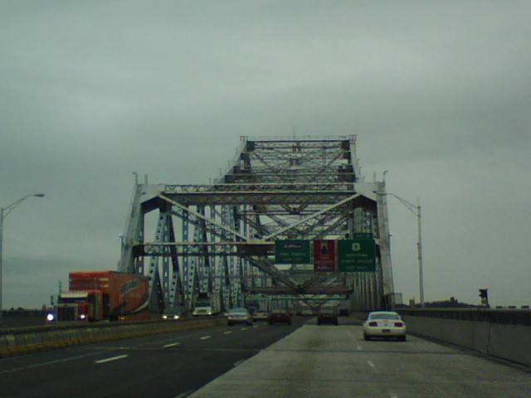

Tappan Zee Bridge East Bound
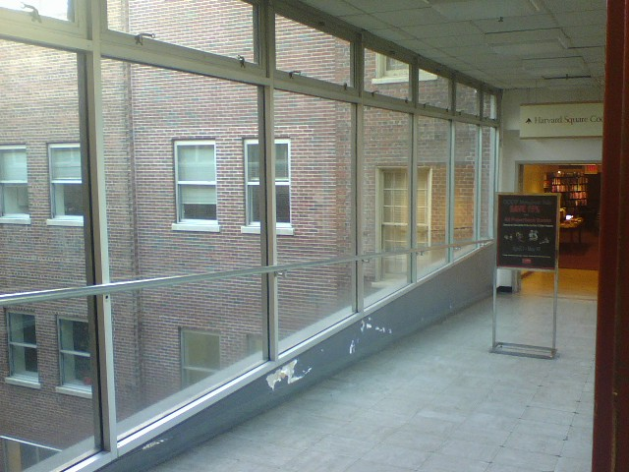

Indoor walking bridge in Harvard Square, Cambridge, MA

