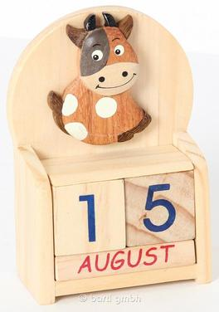
Name: ______________________________________________ Date: ___________ Block: _______
Problem Solving Pre-Assessment
Directions:
1. Read the following problem.
2. Solve the problem.
3. Explain in a paragraph:
- What is your final solution to the problem?
- How did you solve the problem? What methods did you use to help you?
- Did you encounter any dilemmas? How did you find a solution for this dilemma?
Calendar Dice
Mr.Nailos wants to make a “dice calendar” for his daughter’s nursery, which consists of two wooden blocks displaying the day of the month above a block displaying the month. (See image above.) The two date blocks each have 6 sides, with one digit per side. Mr. Nailos is trying to figure out how to number the dice so that every possible date can be displayed. Note: single digit dates would be displayed with a 0, such as 07 or 08.
Your job is to determine how to arrange the digits 0 through 9 on the 2 blocks in order to make EVERY date possible to be displayed. Good luck!

